We must be the change we wish to see in the world-- Gandhi
We must be the change we wish to see in the world-- Gandhi
We must be the change we wish to see in the world-- Gandhi
We must be the change we wish to see in the world-- Gandhi

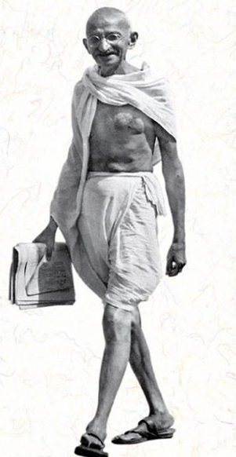
KSU Women’s Center
(785) 532-6444
www.ksu.edu/womenscenter
206 Holton Hall

KSU Women’s Center
(785) 532-6444
www.ksu.edu/womenscenter
206 Holton Hall

KSU Women’s Center
(785) 532-6444
www.ksu.edu/womenscenter
206 Holton Hall

KSU Women’s Center
(785) 532-6444
www.ksu.edu/womenscenter
206 Holton Hall

