PIKEWOOD NATIONAL GOLF CLUB

SUMMER INTERNSHIP PROGRAM
---------------------------------
QUICK FACTS:

  - 2015 #44 “America’s 100 Greatest Courses” - Golf Digest
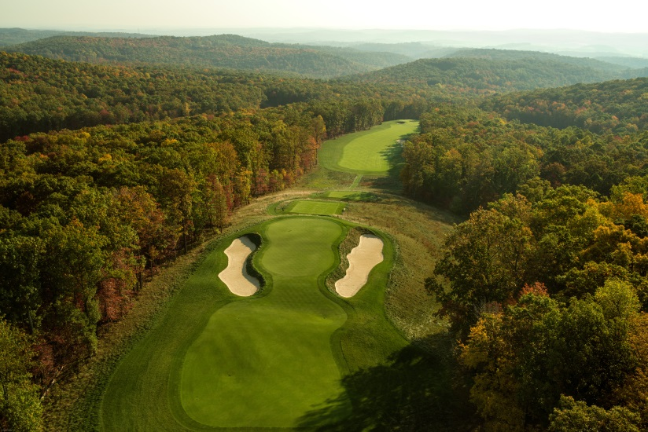
  - 2015 #1 “Best in State” for West Virginia - Golf Digest
  - 2015 #34 “ Conditioning” – Golf Digest
  - 2014 #74 “ Worlds 100 Greatest Courses” – Golf Digest
  - 2009 “Best New Private Course in America” - Golf Digest

  - Located in Morgantown, WV (Home of WVU)
  - 18 Hole private club
  - No pool, no tennis courts, just golf
  - No cart paths, walking only
----------------------------------
A Note from the Superintendent:

Prospective Intern,

I welcome you to explore the opportunities that lie in front of you here at Pikewood National Golf Club; they are endless. Your summer internship is what you make of it. Here at Pikewood, you will be surrounded by a seasoned staff, endless knowledge, and practical experiences that will last you your career, not to mention you will be joining a network that is unparalleled in our industry. We take pride in developing high quality turf professionals. We also have a proven track record of placing student interns at golf courses across the United States to further their careers. The future at Pikewood is ever evolving, with a Master Plan being put in place, as well as the continuation of basic agronomic practices. All that is missing is you.

Regards,
Brett Bentley
---------------------------------
For More Information Visit:
www.pikewoodnational.com

For Internship Opportunities Contact:
Brett Bentley
Golf Course Superintendent
3055 Kingwood Pike
Morgantown, WV 26508
(304) 864-0823
bbentley@greerindustries.com

Pikewood National Golf Club, located southeast of Morgantown, WV, has been ranked by Golf Digest as, # 44 among "America's Greatest 100 Golf Courses 2015, #74 among "The World 100 Greatest Courses" in 2014 and "Best New Private Course" in 2009. In 2011 Link magazine listed Pikewood National #7 on its "Top 10 One-Hit Wonders".
The course takes full advantage of the picturesque West Virginia Mountains boasting breath-taking vistas on nearly every hole. Pikewood National Golf Club is a private 18 hole golf course which is highly exclusive to members who enjoy golf at its purest state. This is a great opportunity to work with a crew that is highly motivated to become successful in this industry.
The ideal candidates are highly motivated individuals who are looking to eventually become a Golf Course Superintendent. These candidates should be self-starters who take pride in his/her work ethic and values the importance of being a team player.
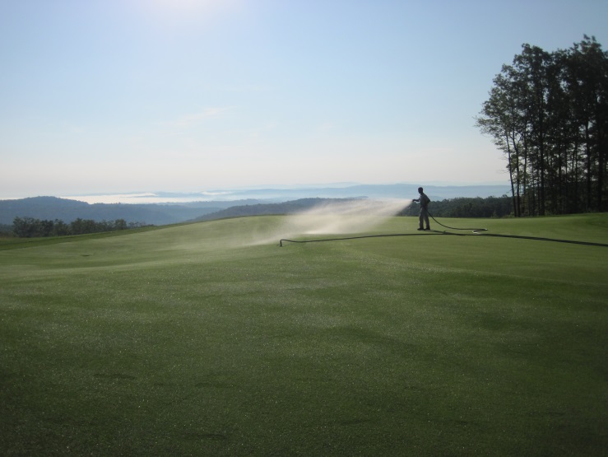
This position will expose the candidate to a wide variety of turf practices. The Pikewood turf crew understands the importance of sound agronomic practices. Such practices include:

- Proper water management (hand watering, ect)
- Fertilization (proper calibration and application)
- Cultural Practices (topdressing, aerification, ect)
- Managing according to weather
The candidate will also be taught the importance of:

- Good communication with the crew, management, and members.
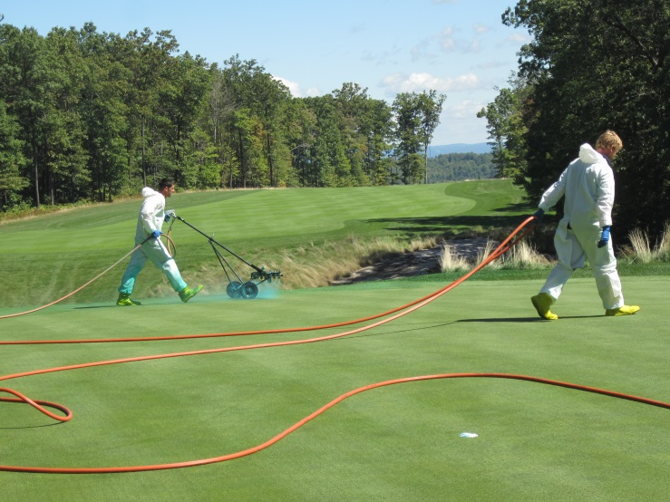
- Professionalism- proper appearance and demeanor.
- Networking.
- Career Preparation.
- Record Keeping (Daily conditions Journal).
For Internship Opportunities Contact:
Brett Bentley
Golf Course Superintendent
3055 Kingwood Pike
Morgantown, WV 26508
(304) 864-0823
bbentley@greerindustries.com
Intern House
Housing is provided on site for prospective student interns. Pikewood National Golf Club has graciously bought and furnished a home for the sole purpose of providing interns who come from various colleges around the country to learn and grow in their chosen industry.

A Few Things to Know:
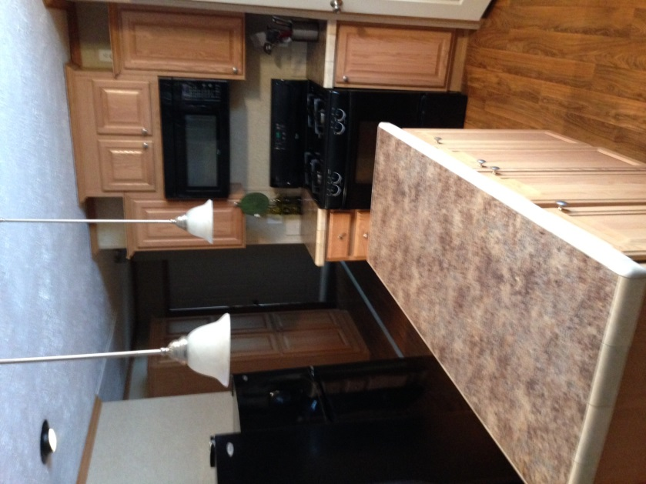
House is fully furnished (6br/3 ba).
- All appliances, including washer/dryer, tv, dvd player.
- All furniture, including living room, dining room.
- All cooking utensils, plates, cups, etc.
- Direct TV basic cable package, wi-fi internet access available
- House is located on golf course property, adjacent to hole #7.
- Front and Rear decks.
- Basketball hoop, ping pong table.
- Ample on-site parking.
- Security System.
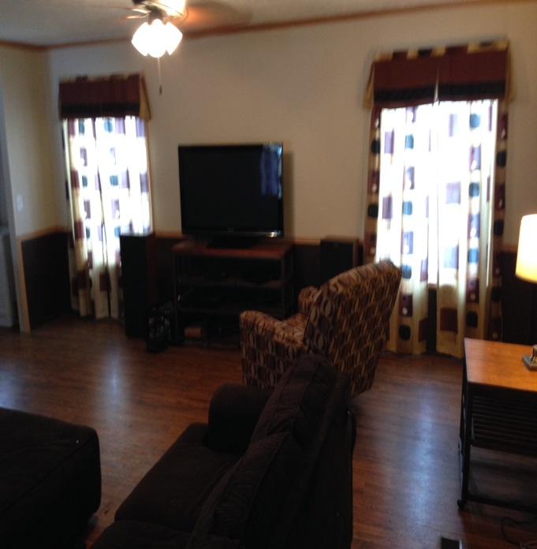
- Grill.
Additional Benefits:
- Khaki Pants, Shirt, Hat and Pullover provided.
- Employee Appreciation outing.
- Internship Dinner with Golf Course Superintendent.
- Employee golf every Monday evening.
For Internship Opportunities Contact:
Brett Bentley
Golf Course Superintendent
3055 Kingwood Pike]
Morgantown, WV 26508
(304) 864-0823
bbentley@greerindustries.com

