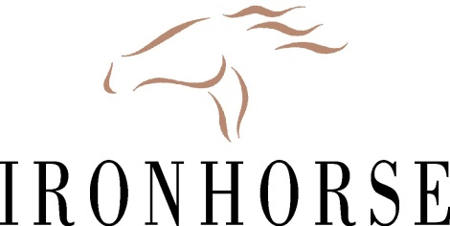

Located in south Kansas City, Ironhorse Golf Club is looking to hire multiple interns for three or six month internships. We are looking for highly motivated individuals that want to lay the groundwork for a successful career in golf course management. This is a great opportunity for students in turf management programs to complete their internship at one of the finest public golf courses in Kansas City. Ironhorse is an 18-hole Championship golf course built in 1994 and is located in Leawood, Kansas. The course is owned by the City of Leawood and managed by Troon Golf.
Ironhorse has ‘Dominant Plus’ Bentgrass greens, ‘Meyer’ Zoysia fairways and tees, and Fescue rough. These grasses will give you a great chance to manage both warm and cool season turfgrasses in the transition zone. This internship will provide you the opportunity to learn daily scheduling of tasks/employees, equipment operation, fertilizer/herbicide calibration and applications, irrigation installation and repair of our Toro Lynx system, and the opportunity to shadow our equipment manager while learning about equipment set up and maintenance.
You will work daily with the Superintendent, Assistant Superintendent, and 2nd Assistant Superintendent to learn many different horticultural practices that will start you on your way to a successful career in the golf course maintenance industry.

Pay: Starting at $10.00 per hour
-Golfing Privileges
-Uniforms
-Discounted Lunches

Please send resume to:
Danny Maisch- 1st Assistant Superintendent
dmaisch@troon.com
913.221.8477

