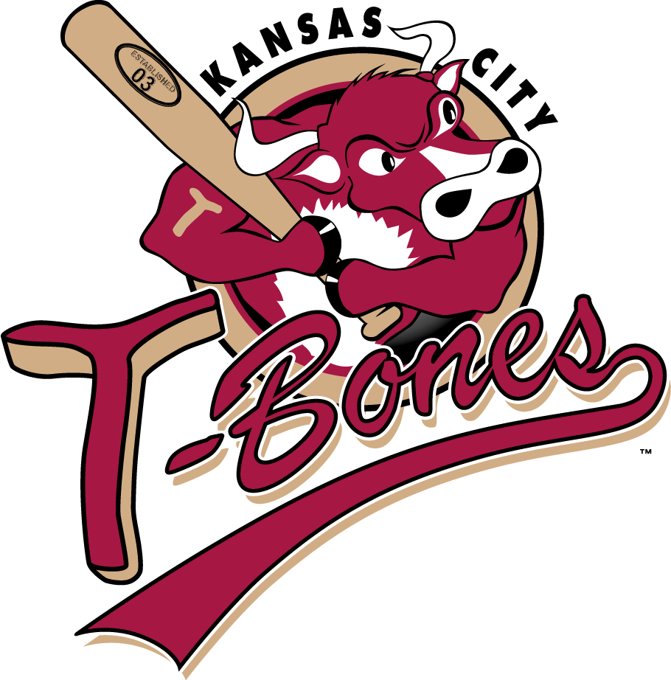

Grounds Crew/Turf Management- Internship Spring 2017
(Mid-March thru Mid-May) Summer internships also available.
Responsibilities include but are not limited to:
- Assist in daily aspects of the grounds operation including Pre/Post Game Work
- Specific duties shall include, but not be limited to:
  - Clay work including infield skin, mounds, home plates, and warning track
  - Turf work including fertilizer and pesticide application, mowing and edging
  - All cultural practices- mowing, aerification, irrigation, topdressing, slicing
- Basic Equipment Maintenace
- Irrigation scheduling and repair
- Tarp handling and weather situations
- Use of a push mower, weed eater, and blower to maintain the berms
- Facilitate set up for baseball and non-baseball related events on the field
- Monitor and maintain an inventory of supplies
- Upkeep of dugouts, tunnel, and trash
  - Qualifications
  - Enrolled in college or have a college degree
  - Ability to lift 50 lbs
  - Ability to function in a fast-paced environment, handle multiple projects and meet deadlines
To apply for this internship, please send a Cover Letter and Resume to:
Nate Miller at nmiller@tbonesbaseball.com or call: (913-328-5654)

