“Staying Active in Aging Improves Health and Well-being”

The Situation
The majority of older adults do not perform strength-building exercises. Reasons include, fear of injuring themselves, no experience with lifting weights, lack of access to a professional experienced with older populations, expense of fitness centers, and few community programs. The death rate from falling in the United States has increased by 30% from 2007 to 2016. Falling once doubles your chances of falling again. The Centers for Disease Control and Prevention’s physical activity recommendations call for strengthening activities that work all major muscle groups at least two days a week in addition to aerobic activities such as walking or swimming. A CDC health survey indicates that only 9.7 percent of Americans 65 and up meet those physical activity guidelines. The nation’s elderly population, estimated at 43.1 million in 2012, will jump to 83.7 million in 2050 according to a 2014 U.S. Census Bureau report. In 2015, the total medical costs for falls totaled more than $50 billion. Medicare and Medicaid shouldered 75% of these costs. In 2014, the total cost of falls among adults age 65 and older in Kansas was reported to be $338 million with $274 million being covered by Medicare of Medicaid.

What We Did
Stay Strong, Stay Healthy (SSSH) aims to provide older adults with access to a safe, structured and effective exercise program capable of building muscle and increasing bone density, thus decreasing frailty, osteoporosis and the risk of falls. The SSSH program is available in 43 local Extension units as an eight-week, 16-hour course which includes pre, post, and follow up participant surveys and pre and post assessments. In 2019, Extension Agents, who are certified instructors, provided sixty SSSH courses totaling more than 960 classes and 739 participants with 82% completion rate. Stay Strong Stay Healthy Level 1 and SSSH Level 2 instructor certification trainings, in 2019, resulted in 8 additional certified instructors at each level. Fifty-seven SSSH instructors maintain CPR first aid certification and participate in training updates to remain current.

Outcomes
A representative sample of program graduates, responding to a 3 month follow up survey, reported the following:
- 60.8% are meeting strength training recommendations and continue strength training routines
- 65.7% are meeting recommendations for stretching and continue stretching routines
- Greater than 80% report strength and flexibility improvement
- 74.6% indicate they sleep better
- 95.8% feel overall health has improved
Participants also reported having a positive change in perceived ability to engage in physical activity, a significantly reduced fear of falling, and a significant increase in social engagement.

Success Stories
An 86 year-old female reported trouble with her flexibility and pain in her right arm. After the program, she was able to tie her shoe without having to prop it on a stool, and her right arm did not hurt as bad. She also reported increased energy and improved sleep. -Finney County

“My shoulder used to hurt something fierce when I tried to sleep; you know, since I've been lifting, it doesn't hurt as bad. I think it’s the strengthening of the muscle and the stretching that is making a difference.” -McPherson County

“Stay Strong Stay Healthy class has helped so much that I can get up and down in the pews at church without getting out of breath!” -Cherokee County

“I was unable to raise my left arm above shoulder height prior to taking this course. Now, I can extend it almost 100% and am able to fasten my back hooks on undergarment. I can walk farther without getting winded as easy.” -SSSH Participant

“Improved my physical balance and renewed my confidence in my physical abilities. Provided a great atmosphere for social interaction while maintaining focus on exercises.”
-Wyandotte County

“The social aspect of the participants who completed SSSH is hard to measure, but their regular attendance and enthusiasm speaks volumes. The post-assessment showed flexibility, strength and balance improved for 96% of the participants.” -Certified Agent Instructor

Contacts
Gayle Price, Extension Specialist 620-820-6123 gprice@ksu.edu
Sharolyn Jackson, Extension Specialist 785-532-2273 sharolyn@ksu.edu
Aaron Swank, Agent, Harvey County 316-284-6930 acswank@k-state.edu
Ashley Svaty, Agent, Post Rock District 785-524-4432 asvaty@ksu.edu

References:
Center for Disease Control and Prevention, Home and Recreational Safety, Older Adult Falls, Accessed October 2019. https://www.cdc.gov/homeandrecreationalsafety/falls/adultfalls.html

CDC’s 2014 National Health Interview Survey

Photos:
Post Southwind District – Joy Miller – SSSH Level 1

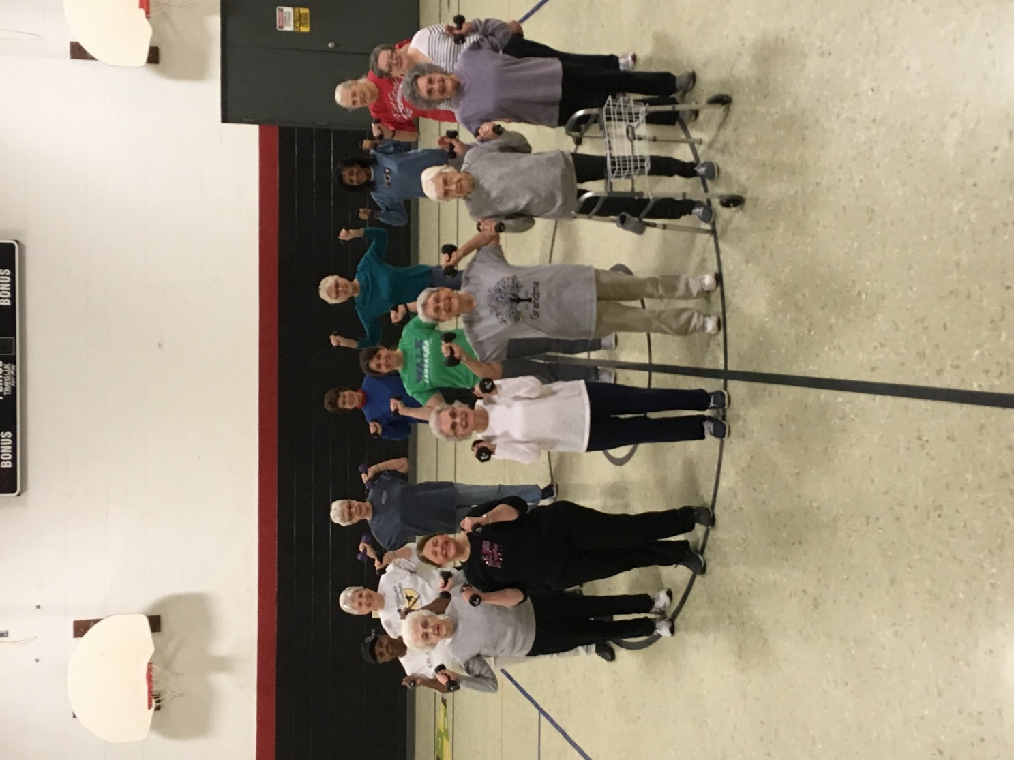

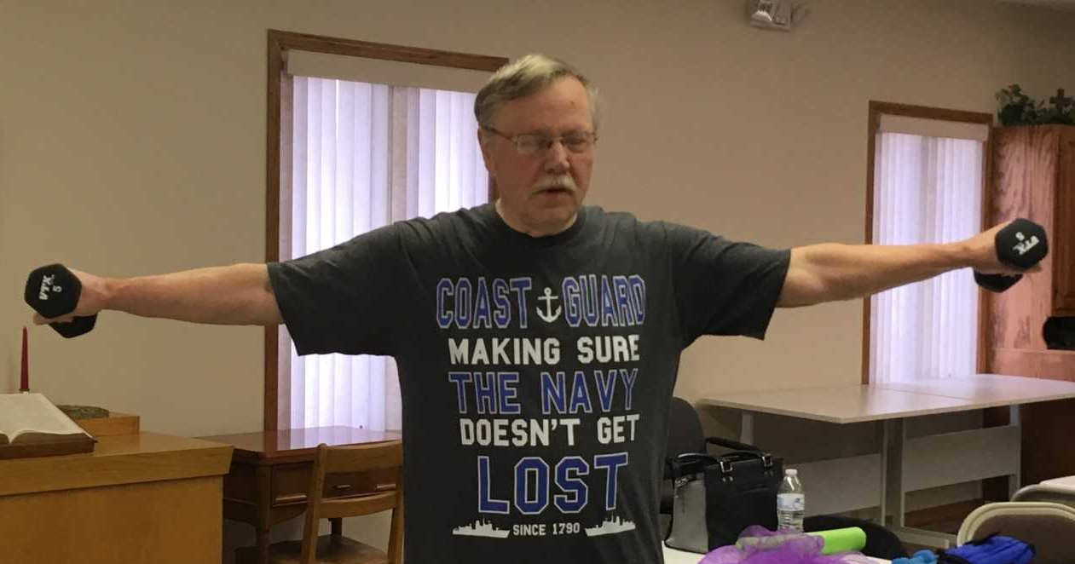

Post Rock District- Ashley Svaty –SSSH Level 1

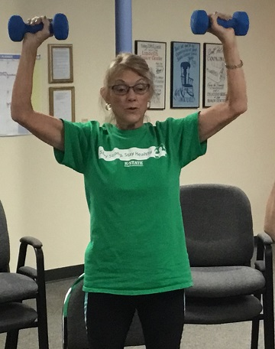

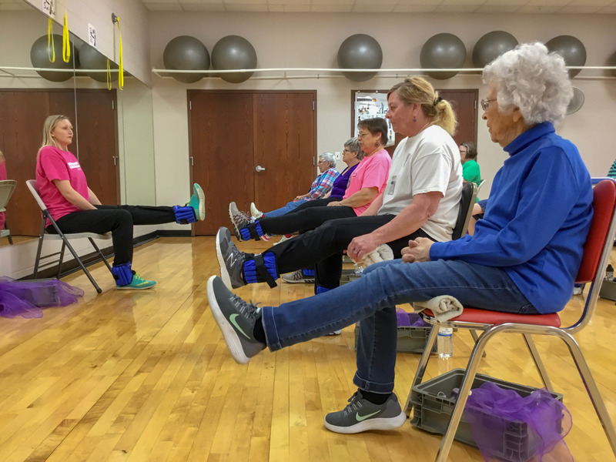

Wildcat Extension District- Tara Solomon-Smith- SSSH Level 1

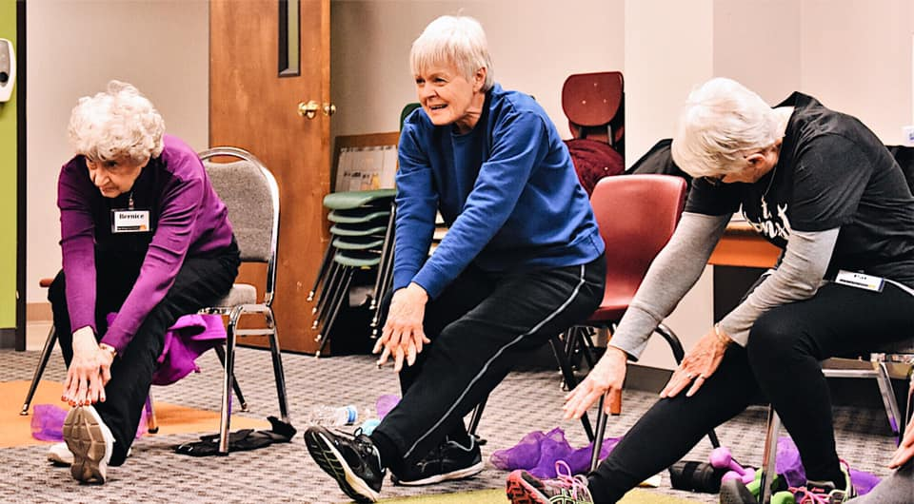

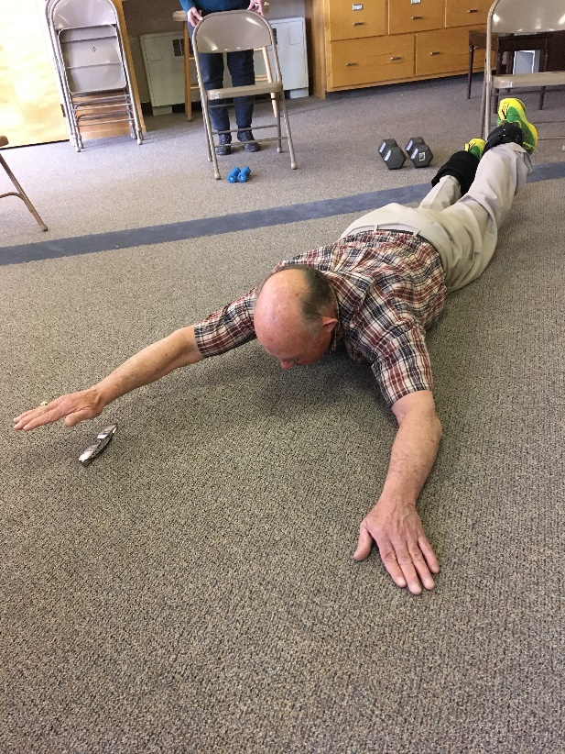
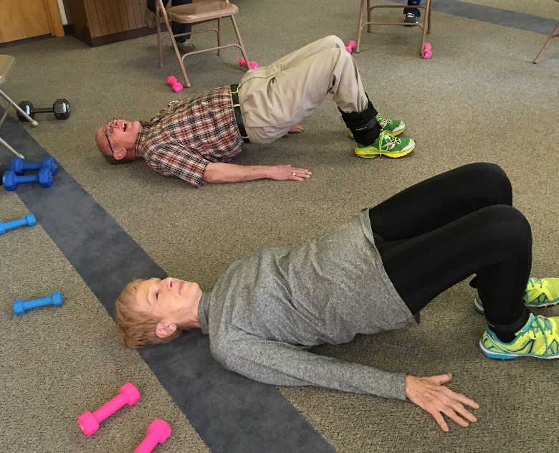
Sunflower District- Melinda Daily- SSSH Level 2

