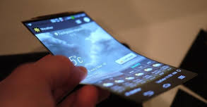
SmartPhone Jingle Selection Sheet

Reviewer’s Name: _________________________________
Select the jingle you feel is most appropriate for use in advertising the new SmartPhone in radio ads.

Name of SmartPhone Jingle selected: _____________________________________________

Composer’s name: _________________________________

List the specific reasons why you believe the selected jingle is appropriate for advertising the new SmartPhone on radio ads:
The most important reason this jingle reflects the SmartPhone:

Describe how the selected jingle can serve as a model for your future composing:

