SmartPhone Jingle Responding Form
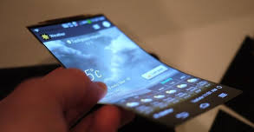
Composer’s Name: _________________________________________________
Listener’s Name: ___________________________________________________
Describe how the elements of music (pitch, rhythm, harmony, dynamics, timbre, texture, form, and/or style/ articulation) are used to promote the new SmartPhone, and portray its characteristics:

Evaluate the composition citing specific examples of how the composition is or isn’t appropriate in style, mood, and/or performance quality for the advertisement of the SmartPhone.

