SmartPhone Jingle Rehearsal Plan Sheet
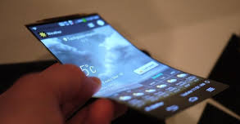
Student Name: ___________________________________

1. Analyze
Does the music sound as I had planned? What parts of the music are
difficult for me to perform?
(e.g., melody, harmony, compositional devices, texture…) (e.g., rhythm, notes, breathing, phrasing, dynamics…)
2. Interpret
How can I expressively use elements of music to portray the SmartPhone, and serve as memorable music
to promote the SmartPhone product?
(e.g., dynamic contrast, phrasing/text painting, tempo variety, tonal manipulation…)
3. Rehearsal Plan
How will I learn the music and address musical problems to achieve an accurate and expressive performance?
(e.g., rhythmic accuracy, diction, meaning of text, defining terms, technical and expressive skills…)
4. Evaluate & Refine
Do I perform this selection more accurately/expressively than I did when I began? Can I make more improvements?
Analyze:
Interpret:
Rehearsal Plan: goals/strategies/processes for improvement across rehearsals
Evaluate and Refine: Checking results – How have I improved and what can I do better?

