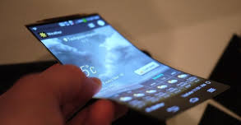
SmartPhone Jingle Imagination Sheet

Student Name: ________________________________
Use this sheet to brainstorm and describe ideas: e.g., sounds, sequences, textures, timbres, dynamic shapes, melodic/harmonic ideas that could be used for your music composition (SmartPhone Jingle). These ideas should relate to the SmartPhone product, and will be used in the planning and making of your jingle. In your jingle, the musical elements (including tempo, rhythm, dynamics, and timbre) are to be used to portray the characteristics of the new SmartPhone product.

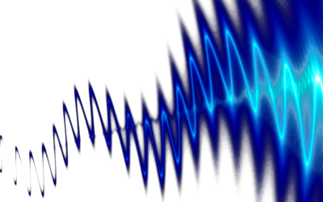
Sounds

Sequences

Textures

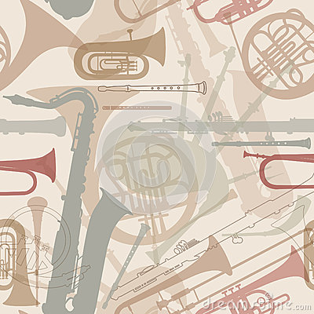
Timbres

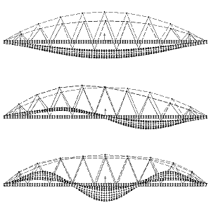
Dynamic Shapes

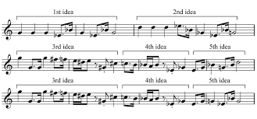
Melodic/Harmonic Ideas

