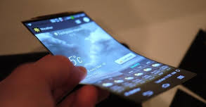
SmartPhone Jingle Analysis Form
Student Name: ___________________________________
Identify and describe the various ways you might use the elements of music to serve as memorable music to promote the SmartPhone product, and portray the characteristics of the new SmartPhone in your jingle: elements of music (pitch, rhythm, harmony, dynamics, timbre, texture, form, and/or style/ articulation)
Rhythm, Articulation:
Melody, Harmony, Texture, Timbre:
Dynamics:
Form, Style:
Teacher Feedback:

