MEDIA
SERVICES
Documentary Theme Song Imagination Sheet
Student Name: ________________________________
Use this sheet to brainstorm and describe ideas: e.g., sounds, sequences, textures, timbres, dynamic shapes, melodic/harmonic ideas that could be used for your music composition (Documentary Theme Song). These ideas should relate to the documentary’s topic, and will be used in the planning and making of your theme song. In your theme song, the elements of music (pitch, rhythm, harmony, dynamics, timbre, texture, form, and style/ articulation) are to be used to represent the documentary’s topic.
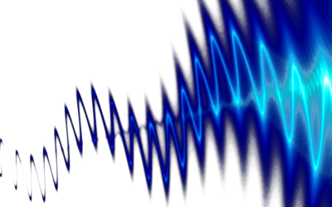
Sounds

Sequences

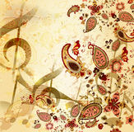
Textures

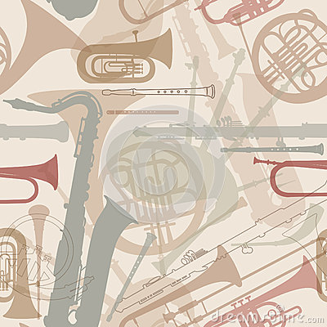
Timbres

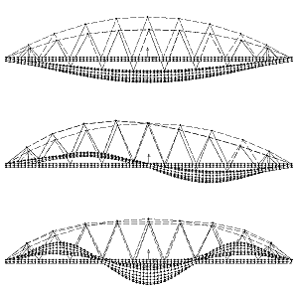
Dynamic Shapes

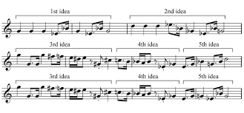
Melodic/Harmonic Ideas

