Creating Enrollment Requirement Groups for Requisites and Reserved Capacity
HELP

Navigation: Curriculum Management> Enrollment Requirements>Enrollment Requirement Groups

To find/update an existing enrollment requirement group:
“Find an Existing Value”
Enter desired Search Criteria such as:
Requirement Group = to search by the 6-digit ERG number
OR
Subject Area and Catalog Nbr: to search by course
Click “Search” button

To add a new enrollment requirement group:
Click “Add a New Value” tab
Requirement Group = 000000 (leave this default value)
Click “Add” button

TIP: You may want to search first to see if rule(s) for the course already exist

***Course Requisite tab***
--This page is used to describe the enrollment requirement group

If you are adding a new value, then proceed to populate the fields
If you are updating an existing ERG, then click (+) icon to add a new row

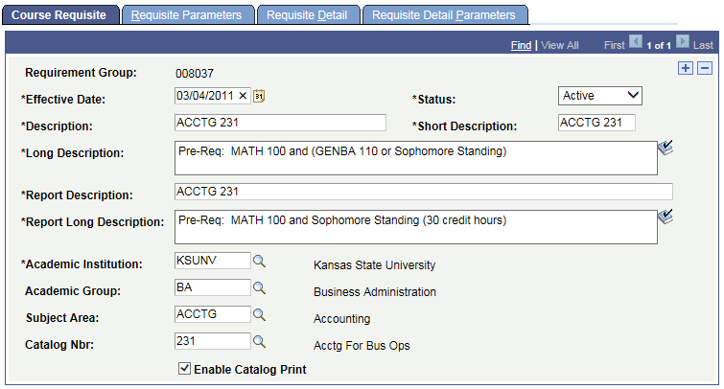

Abbreviations:
ERG=Enrollment Requirement Group
*=Required field
*Effective Date
TIP: ERG Effective Date must be LE Course Effective Date
ERG Effective Date must be LE Term Start Date
(must be BEFORE or EQUAL)

For Reserved Capacity rules, ERG Effective Date must be LE Term Start Date

Values:
--use standard dates when possible (1-1-, 5-1, and 8-1-yyyy)
--in some cases the Effective Date on the KSIS Course Catalog needs to be changed (contact Academic Scheduling)

--allows for changes in the ERG over time while maintaining a history of those requirements. The system will utilize the appropriate ERG based on this date.

--if the dates are not correct, you may not be able to select the ERG when adding to the course
--if the dates are not correct, you may be able to see/select the ERG but the descriptions displayed with it may be old

*Status:
Indicates whether or not the ERG should be evaluated during enrollment:

Values: Active or Inactive

Note: if you want to inactivate the ERG, you also need to delete the number from each course to which it is attached on the Catalog Data page (contact Academic Scheduling)

*Description:
For standardization the following formats should be used:
--length=30

For ERG identified with a course:
Use full course number of the course this rule applies to
--this is intended to make it easier to find an ERG associated with a specific course
i.e. ACCTG 231

For ERG identified with specific class sections:
Use full course number, appended with “specific sections only”
i.e. CIS 490 (specific sections)
i.e. MANGT 420 (Salina sections)

For ERG identified with Reserved Capacity on class sections:
Use “Res Cap:” followed by full course number
TIP: it may be helpful to include additional descriptive text for reserved capacity rules as this description is displayed in the Maintain Schedule of Classes page.
i.e. Res Cap: FOR 330 – BIOL (this is the rule for BIOL majors only)

For ERG identified with Global Campus class sections:
Begin descriptions with Global:

For ERG needing other special notations:
You may include other distinguishing descriptions about the rule as needed
Example: CIS has multiple Reserved Capacity Rules for CIS 300
“Res Cap: CIS 300 3.0 rule” and “Res Cap: CIS 300 SR rule”
Expanded descriptions make it easier to identify which rule is used in the Reserved Capacity tab on the class section

Note: When creating a new requisite, when you type in “Description” and then click or tab to the “Long Description” field, the default description is automatically copied to “Long Description”, “Report Description”, and “Report Long Description” fields
--adjust the remaining descriptions fields as needed
--this does not occur if you are updating the Description field for an existing ERG

Description displays in: Course Catalog and Reserved Capacity pages

*Short Description:
Use full course number

*Long Description:
--length=unlimited
For standardization, begin with one of the following, followed by a worded description of the requisite rule
Pre-Req:
Co-Req:
Res Cap:

--Example: Pre-Req: MC 303 or MC 406, and senior standing
--Example: Pre-Req: MANGT 420 (Salina sections) cannot be taken by College of Business students
--Example: Res Cap: FOR 330 – BIOL majors only

Use the “spell check” icon, if desired

TIP: this is the worded description of the ERG; it does not control the coding of the rule

--Long Description displays in the Course Catalog, Class Schedule description (if the Enable Catalog Print box is checked), Class Search>Class Details page and in enrollment screens for the student.

*Report Description: same as “Description”
--believe this displays in PERC

*Report Long Description: same as “Long Description”

*Academic Institution: KSUNV

Note: Populate the following three fields for ERG identified with specific courses. The system does not include these values in the analysis of the ERG. These values are helpful tools for searching the database.

Academic Group:
Identified by whom it will be maintained (college)

Subject Area:
and
Catalog Nbr:
--identifies which course the ERG is designed for

Enable Catalog Print: ON
Select this checkbox to display the Long Description of the ERG in the Course Catalog

***Requisite Parameters tab***
TIP: the Course Credit Parameters on this page are typically NOT used

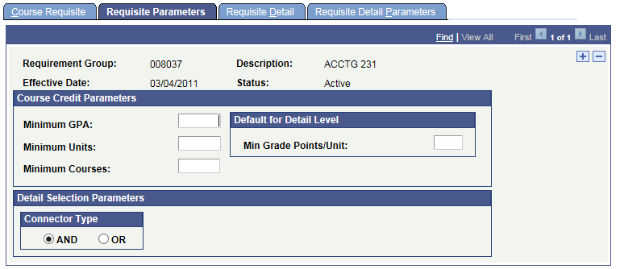

Course Credit parameters are overall criteria that the system uses in the evaluation of all combined requisite detail lines that follow.
--the gpa and unit minimums that you enter direct the overall restrictions for all the courses that you specify on the following pages
--the “Course Credit Parameters” area of this this page will typically not be used
--contains restrictions that apply to all courses selected
Example: if the requirement stated that a minimum gpa of 3.0 over a series of courses was required, then 3.0 would be entered in the Minimum GPA field before moving on to the next page

Minimum GPA
--enter the overall minimum gpa for classes that are selected to meet this requirement (for classes on the following page)

Minimum Units
--enter the total minimum units for the classes that are selected to meet this requirement

Minimum Courses
--enter the total minimum courses for the requirement

Min Grade Points/Unit:
--enter the minimum grade points/value that are required for any individual class that is selected to meet the requirement. The system includes a student’s in-progress work as counting toward the minimum.

Connector Type:
TIP
For ERG with more than one requisite detail line, select the appropriate connector type.
--the connector type indicates whether the student must meet all of the requirement line detail conditions (AND) or whether the student only needs to meet one of the requirement line details (OR).
--the value is used as the connector default on the Requisite Detail page when rows are inserted.
--controls how the system groups lines
--affects your results
--consider changing the “Connector Type if parentheses are not placed in the desired location

***Requisite Detail tab***
--this page is the core of the logic for the ERG
If you are adding new criteria within a rule, then click (+) icon to add a new row
If you are removing criteria, then click (-) icon to delete
If you are changing criteria, then make change to existing row

TIP: Click “View All” to view all rows at once
After completing and saving a complex rule, it may be helpful to click “View all” to review your rule, paying close attention that the grouping and parenthesis accurately display the rule

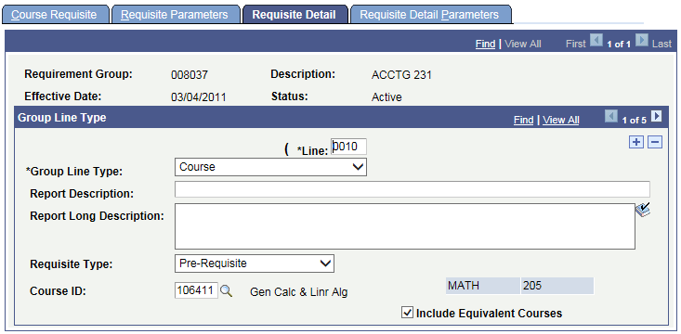

And/or
--only available when more than one detail line is present
--the operator used between two requisite detail lines
Values:
AND: student must meet all of the requisite line detail conditions
OR: student only needs to meet one of the requisite line detail conditions

Parentheses:
--Parentheses are used in grouping statements and determine how a complex statement is interpreted
TIP
--you cannot explicitly set parentheses to group detail rows
--if the main connect type is AND, then the system automatically groups ORs together with parentheses
--if the main connect type is OR, then the system automatically groups ANDs together with parentheses
--consider changing the “Connector Type” on the Requisite Parameters tab if the parentheses are not placed in the desired location
--you can see where () have been placed, but you cannot set () yourself. The connector type controls that.
--system does not allow nested (); every statement must be normalized even if that means repeating variables.

Line:
--the system generates the line number
--the number determines the order in which the system evaluates the detail lines
--you can change the number, but no two lines can have the same number
--default in increments of 10
--lower lines numbers are processed first
TIP: use (+) in the Group Line type region to add a new row within the rule
Use (-) to delete a row
Or modify existing row as needed

*Group Line Type
--indicates what type of requirement will be configured
--the value selected determines what other fields are available on the page

**Values: Condition, Course, Requirement, Wild Card Course

Report Description and Report Long Description
--Leave blank

**Condition—specify allowable values of data elements associated with a student
Condition Code:
Academic Level (uses Projected Academic Level)
Academic Plan
Academic Plans
Academic Program
Academic Programs
Academic Standing
Academic Sub Plan
Academic Sub Plans
Cumulative Grade Point Avg.
Dynamic Condition
Primary Academic Plan
Primary Academic Program
Student Group
Student Groups
Test Score

Condition Operator:
Equal
Greater Than
Greater or Equal
Less Than
Less or Equal
Not Equal

Condition Data:
Select from LOV for the Condition selected

For specific values, see separate document: “Requisites CONDITIONS”

**Course—specific course student must take to fulfill the requisite
Requisite Type:
--Pre-requisite: something a student must complete before the start date of the desired class
--Co-requisite: something a student must complete prior to, or at the same time as, the desired
class
--Course ID: select desired course
--be careful if you have course number changes involved; select the appropriate Course ID
--consider adding all courses you will commonly accept as a pre-requisite
--example: STAT 350, 320, 325, 330
--Include Equivalent courses:
If CHECKED:
--allows equivalent course to satisfy this requisite (KSU has not defined this special functionality)
--does not display the optional fields: Term, Associated Class, Topic Id
TIP: for new rules the default is UNCHECKED, click to CHECK it, which will hide the
additional fields which are typically not used
--Optional: Term, Associated Class, Topic ID:
Use to further specify the term and specific class section or topic that must be taken
--If “Include Equivalent courses” is checked then these fields are not displayed

**Requirement—use to incorporate a more complex Enrollment Requirement defined elsewhere in the system
Requirement: examples in iSIS: 000010001 Any Math Class 100 or higher
000001172 Secondary Education Plans
Requisite Type: Pre-requisite or Co-Requisite

**Wild Card Course—specifies a range of courses based upon subject area and catalog number
--specify as few or as many criteria as you want using the Academic Group, subject, and Catalog Nbr fields

Academic Group:
--academics group designate colleges (AG, AR, AS, etc)
Subject:
--use asterisk (*) as the wildcard for the alpha portion of catalog number
Catalog Nbr:
--use the pound sign (#) as the wildcard for the numeric portion of catalog number
Notes:
--wildcard requisites do not check equivalent courses (special functionality KSU has not defined)
--wildcard requisites DO check transfer courses
--blank fields return all values

--you can select Wild Card Course and Pre-Requisite only, leaving Academic Group, Subject,
and Catalog Nbr blank. This creates a set of all courses taken. Then you can also enter values on the following Requisite Detail Parameters page to define limits on those courses.

TIP: Wild cards are helpful if you want to code a requirement such as “any STAT course”
--use STAT ### or STAT and leave Nbr blank

Examples:
ENGL 1## = any ENGL courses beginning with 1

***Requisite Detail Parameters tab***
--contains data that applies to ONLY the corresponding course and/or wild card courses selected on the Requisite Detail tab
--is not displayed for “Condition” and “Requirement” rows

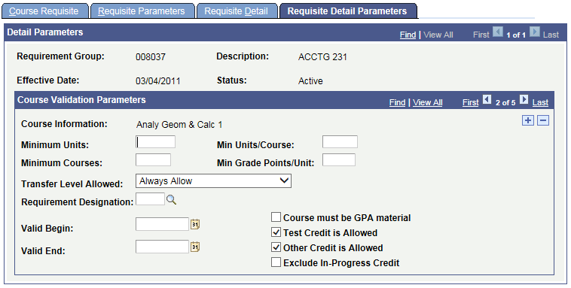

Minimum Units:
--enter the minimum Units that are required for the course or wildcard course for this requisite detail line

Min Units/Course:
--enter the minimum units per course value to indicate the minimum number of units that a single course must be worth to be evaluated.
--example: if set to 3, the system picks up only courses that are worth three units or greater

Minimum Courses:
--enter the minimum number of courses that are required of the wild card course you specify
--example: if you set this to 2, the system looks for at least two courses in the wild courses you specify.
When the system finds at least two courses that match then the requisite is satisfied.

Min Grade Points/Unit:
--enter the minimum grade points per unit that each course must have to be used to satisfy the course requisite.
--TIP: commonly used to specify if a minimum grade is needed in each pre-requisite class
--example: If you set this to 2, then each course must be a grade C or greater to be evaluated
--if need grade of C or better use 2.00
--if need grade of B or better use 3.00
--if need grade of A use 4.00

Transfer Level Allowed:
--Indicates what type of transfer credit (if any) can be used to satisfy requisite
Values:
Always Allow – all applicable transfer credit can be used (default)
Never Allow – transfer credit can never satisfy the requisite
Two Year Institution Only – only transfer credit from two-year institutions can be used
TIP: If transfer courses have direct equivalencies to KSU courses, and the KSU courses are named in the requisite rule, then the rules will allow the transfer courses to meet the rule if the “Transfer Level Allowed” is set to “Always Allow”

Requirement Designation:
--select the requirement designation that each course for this requisite detail line must possess to be evaluated
--K-State 8 values are Requirement Designations

Valid Begin:
Valid End:
--specify the date range when the courses must be taken to satisfy the requisite.
--leaving blank means that it does not matter when the courses are taken
--when system compares the date range, it uses the start and end dates of the term in which the course was taken
--for transfer courses, the system uses the start date and end date of the articulation term

Course must be GPA Material:
--select to require that courses evaluated for this requisite must be applied toward the student’s career GPA calculation.
--example: to exclude credit/no credit grades
--default is NOT CHECKED

Test Credit is Allowed:
--select to allow test credit courses to be evaluated
--default is CHECKED

Other Credit is Allowed:
Select to allow other credit courses to be evaluated
--default is CHECKED

Exclude In-Progress Credit
--if the course that the student takes to satisfy this requisite must be fully graded for the system to consider it valid, select this check box
--if check box is cleared, the system will include in analysis and pass all parameters any nongraded courses, as well as any graded courses that have In-Progress (such as incomplete courses)
--leaving this check box cleared is the least restrictive, and allows for maximum user/student flexibility
--default is NOT CHECKED

RELATED TOPICS

Assigning ERG to Courses
Navigation: Curriculum Management>Course Catalog>Course Catalog>Offerings tab
Enrollment Requirement Group area

Update KSIS Course Catalog to attach the rule to the COURSE
Must be performed by Registrar’s Academic Technology unit
In Curriculog, submit the “Course – System Request” form
--Select changes requested: choose ‘Attach Enrollment Requirement Group”
--Select Effective Term
--Attach Enrollment Requirement Group: enter 6-digit number representing the ERG
--the rule will not be in effect until this step is performed

View KSIS Course Catalog page to find the ERG currently assigned to the COURSE
--includes the ERG number and Description
--you can also click the “Detail” link to view a summary of the ERG
--however you cannot view the Requisite Detail Parameters assigned to any of class courses listed in the rule

Check the Effective Date of the course
--click Catalog Data tab
--if the Description displayed appears to be for a prior rule, compare the Effective date of Course to ERG
TIP: ERG Effective Date must be LE Course Effective Date
ERG Effective Date must be LE Term Start Date

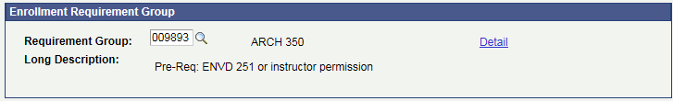

Assigning ERG to Class Sections
Navigation: Curriculum Management>Schedule of Classes>Adjust Class Associations
--search for the desired class section using term, subject area, catalog nbr
--Select the appropriate Session in the search results, if more than one session is displayed
--use the arrow keys to navigate to the correct “Associated Class”
--you will need to locate it using the Session and Associated Class (1-Regular or NST-NonStandard)
--not by using Class Section or Class Nbr
--Click “Class Requisites” tab

If an ERG is assigned to the “Course” it will be displayed in the “Catalog Requisite” area

Class Association Requisites region

Also Use Catalog Requisite checkbox: CHECKED
--default usage is CHECKED; there may be specific cases where this can be UNCHECKED

Requirement Group = enter or select the desired ERG

Long Description = is automatically displayed once you tab out of Requirement group field

--added by Class Schedulers
--if attached to class then they do rollover to next term (fall to fall, spring to spring, summer to summer only)

SAVE

Assigning ERG to Reserve Capacity:
See separate document “Reserve Capacity HELP”

Grad Requisite Bypass:
--Allows graduate students to enroll in classes even if they have not passed the requisite rule. The department desires that the requisite rules be enforced for UGRD students, but not for GRAD students..
--the department is responsible for including this requisite rule on their courses
--many times it is an oversight if it is not included
--uses Entity Group 000014 Grad prereq by-pass
This entity group lists the programs that when a student is admitted to them permits the student to by-pass any undergrad requisite rule
Entity Group Type: Program
Academic Programs:
AGGDG ARGDG ASGDG BAGDG EDGDG ENGDG GRDG HEGDG VMGDG
AGGND ARGND ASGND BAGND EDGND ENGND GRND HEGND VMGND
--Rule: CONDITION “Academic Program” IN “000014”

Global Gen Crse Enrl Stop:
--Prevents Global campus only students from taking on-campus classes
--the department is responsible for including this requisite rule on their class sections
--uses Entity Group 000015 DCE Plans
--This entity group lists the plans that non-degree Global Campus students are generally placed in;
these students are not permitted to take an on-campus classes
--Description: Global Campus: Student in Global Campus non degree programs may not take this class. Please select a Global Campus section.
--Enrollment Requirement Group: 010008 Global: Gen Crse Enrl Stop
--used in Adjust Class Associations>Class Requisites tab for a class section
--Rule: CONDITION “Academic Plan” NOT IN “000015”

PERC (Post Enrollment Requirement Checking)
Students who are currently enrolled in a class that is used in an Enrollment Requirement Group for the subsequent class may be “conditionally” enrolled. Post Enrollment Requirement Checking (PERC) verifies that the enrollment requirement group rules have been met after grades have been posted. It compares information from the student’s record against requisite rules that have been built in Enrollment Requirement Groups and identifies them as either Satisfied, Not Satisfied, or Conditional. It also provides the ability to drop students who remain not satisfied, if desired.

Enrollment
Requisites:
--if student does not meet requisite rules then enrollment is not allowed
--nor can the student be added to the waitlist
--TIP: if you wish to allow a student to enroll or waitlist that does not meet the rule, than grant a “class permission”
--by default a class permission overrides requisites
--students on waitlist may be auto-enrolled into the class when a seat is available
--if you add a student to the waitlist by Quick Enroll using “Override Requisites” then that override will not apply to auto-enroll process

Reserve Capacity:
--if a class has Reserve Capacity but you wish to let student enroll, then use Quick Enroll “Override Closed Class”

Anti-Requisites
Building a requisite to prevent enrollment in one course if student has already successfully completed another course
--contact the Registrar’s Office

Enrollment Requirements
“Enrollment Requirements” are intended for more complex requisites that cannot be accomplished using Enrollment Requirement Groups (ERG) alone.

“Course Lists” may be useful for creating a series of courses that must be met to fulfill pre-requisite or co-requisite requirements. They are especially useful for requirements that contain a long list of courses that are not easily grouped together. For example, the requisite might state that 6 units must be completed from any social science course before enrolling in the desired course. A Course List could be created for all social science courses and the appropriate Course List could then be referenced in the Enrollment Requirement Group before being attached to the course.

If Enrollment Requirements and/or Course Lists are deemed necessary, contact the Registrar’s Academic Technology unit who will work with the colleges independently to set these up.

The Group Line Type of “Requirement” is selected in the ERG and then the appropriate Requirement is selected
Examples:
Requirement: 000010001 Any Math Class 100 or higher
000001172 Secondary Education Plans

Problem Solving
If a rule is not working as expected:

Click “View All” to view all rows at once, paying close attention that the grouping and parenthesis accurately display the rule

Check Effective Dates
TIP: ERG Effective Date must be LE Course Effective Date
ERG Effective Date must be LE Term Start Date

If the Description displayed appears to be for a prior rule, check effective dates as described in above TIP

If you need additional assistance, contact the Registrar’s Academic Technology unit and provide the following:
Example of student who cannot get enrolled, course, error message if known

Oracle/PeopleSoft HELP:
When logged into KSUCSTST, click on the “Help” link
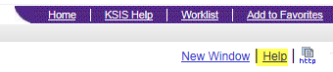

Reports:
For Registrar use only
Query on CRSE_OFFER for course level
Query on CLASS_ASSOC for class level

