KANSAS STATE UNIVERSITY
HONOR & INTEGRITY SYSTEM
Annual Report
2010-2011

Article VI of the Honor & Integrity System Constitution requires the Director provide a report to Student Senate, Faculty Senate and the Provost annually. This report summarizes the activities of the Honor System for the 2010/2011 academic year.

The primary purpose of the Honor & Integrity System is to promote academic integrity as a standard of expectation within the university community. With this purpose in mind, the system seeks to promote academic integrity through both education and adjudication. This report will emphasize both of these missions as well as provide a report of the system changes and administrative activities of the Director and Honor Council during the reporting period.

ADJUDICATION:
Cases Reported

The Honor & Integrity System has processed 154 Honor Pledge Violation reports. This number represents an increase of 20 cases over the 2009-2010 academic year. The chart below summarizes the total number of violation reports received by the Honor & Integrity System since 1999. The 2010-2011 numbers represent the greatest number of cases reported for any given year.

Figure 1 represents the number of violation reports received by the Honor System since the inception of the system in 1999. Please note, the numbers represented in the figure reflect only the violations officially reported to the system. These numbers do not include, informal consultation with faculty regarding violations not reported, nor do they include instances discovered by faculty who choose to handle the violation themselves. It should also be noted, Kansas State University does not have a mandatory reporting policy for academic dishonesty. However, faculty should report violations which result in an academic sanction which adversely impacts the student’s grade. The Honor & Integrity System has established procedures by which students may contest academic sanctions related to allegations of dishonest conduct.

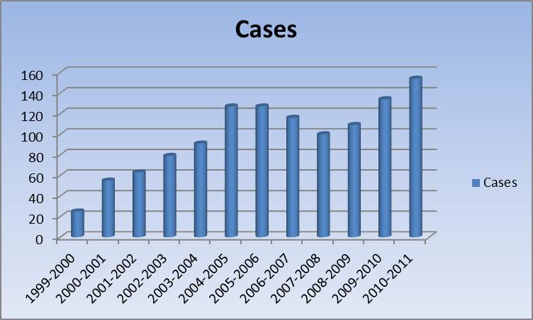
Figure 1: Violation reports by year.

Faculty Demographics

Reports were received from all levels of teaching faculty (See Figure 2). Tenure track faculty constituted 46.6% of the violation reports received while instructors accounted for 37.3%. Graduate Teaching Assistants filed 10% of the reports and 6% of the reports were filed by administrative personnel including Deans, Department Heads, and Program Coordinators. The greatest number of reports was filed by instructors. This is a sharp increase from the previous year when instructors only accounted for 15.27% of the reports filed. However, the data is consistent with years prior to 2009-2010 when instructors constituted the majority of reports filed with the office.

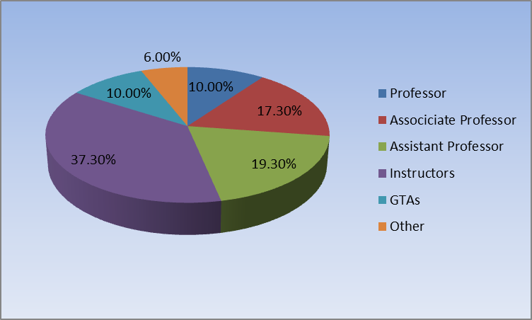
Figure 2: Reports filed by rank.

ADJUDICATION:
Students Reported for Violations

During the reporting period, 188 students were alleged to have committed violations. This is an increase of 7 students from the previous reporting period. A comparison of data from the two reporting periods indicated the overall number of cases reported increased by 20 and the overall number of students increased by 7. One should note, there does not exist a direct correlation between the number of cases reported and the number of students reported. Cases are frequently reported in which multiple violators are named as having violated the academic integrity standards at the university. If the sanctions are the same, and the violation is related, the Honor & Integrity System assigns one case number to the violation. Figure 3 represents the number of students reported as compared to the number of cases reported by year since 1999.

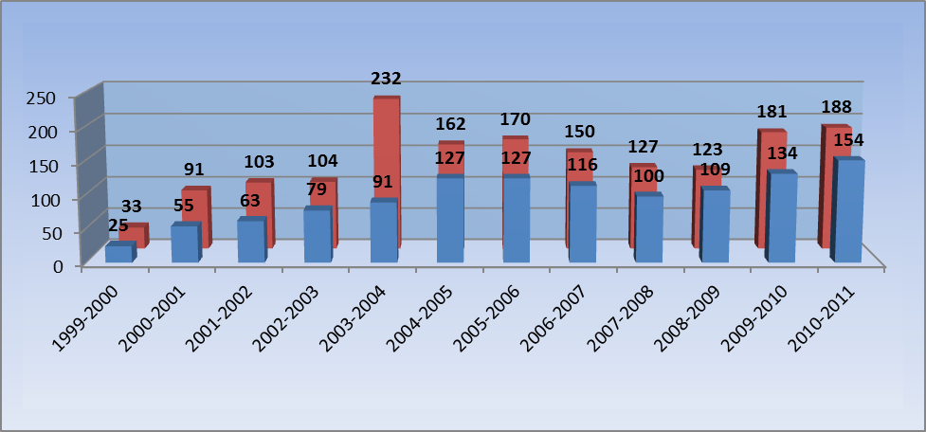
Figure 3: Cases/Students reported since 1999.

Student Demographics

Of the 188 students reported in 2009-2010, 108 students were male and 80 were female. Of the188 students 161 have been sanctioned for violations. Of the remaining 27 students, 4 students’ cases were dismissed by the Case Investigators, the remainder are awaiting the beginning of the fall semester to begin the investigation and adjudication process. All but one of these cases were filed at the end of the Spring 2011 semester.

A breakdown of the students by classification can be found in the following chart. Violations committed by seniors represented 26.6% of the total number of violations, this increased from 21% in the previous year. Additionally the number of violations committed by juniors made up 23.04%, a slight decrease from the previous year. The number of violations by graduate students represented 14.40% of the total violations, a 4% increase over the prior year. The number of violations by upperclassman demonstrates approximately 64% of the total violations were committed by upperclassman. This percentage is consistent with the percentages reported during the previous reporting period.

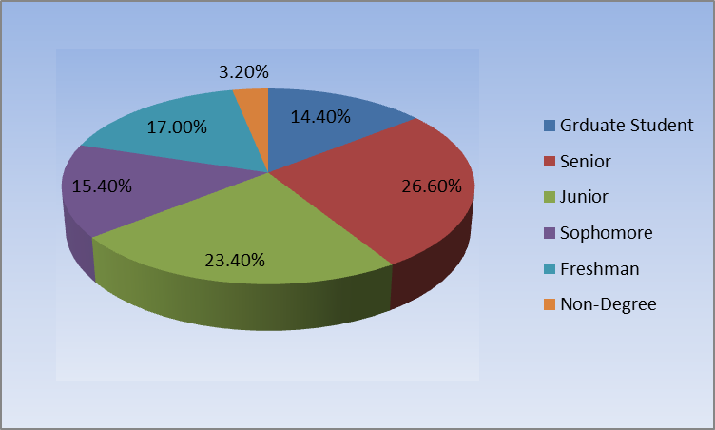
Figure 4: Percentage of violations reported by class.

Second Violations

Of the 188 students thirteen had previously been reported to the Honor & Integrity System. These students are required to appear before a hearing panel to decide if further sanctions are necessary. As per the FERPA regulations our office is not authorized to share previous violation reports with faculty. Therefore, at times the sanctions applied for violations in one class may not be suitable for someone who has committed the violation previously. Therefore, each case and subsequent sanction is reviewed by a hearing panel and a sanctioning determination is made.

Eight of these students have appeared before a hearing panel and hearings for the other five will take place early in the fall semester. In reviewing each of the second violation reports, hearing panels opted to elevate the level of sanctioning in all instances. Two students were recommended for suspension. One of these students was suspended and one was not. In both cases the recommendations were forwarded to the Provost who independently review the case files, and after consideration made the final decisions.

The other six students were given additional sanctions including, community service hours to be performed in conjunction with the activities of the Honor & Integrity System, the requirement to complete the Development and Integrity course, attend various department sponsored workshops on plagiarism, and revise papers to be evaluated by the either the Director or Associate Director of the Honor System

Adjudication: Investigations and Hearings

The Director forwarded 40 cases to the Honor Council for adjudication, seven of which were cases carried over from the 2009-2010 academic year and 14 of these cases have yet to be resolved. Of the 25 cases filed and adjudicated during the reporting period, Case Investigators recommended dismissing four of the cases for lack of information. Two cases were closed when the Alleged Violator was given access to the Case Investigation report prior to the hearing date. At that time both student’s elected to waive their right to contest the violation reports. Of the other 19 cases all cases were closed following the adjudication process. All cases were ruled in favor of the reporting faculty with the exception of one case. In that case the students were found not responsible for an Honor System Violation. The student records were sealed and their personal data was removed from the Honor System database.

Forms of Violations and Sanctions

In past years, the largest form of Honor Pledge Violations involved plagiarism. However, during the reporting period 60% of the cases filed were identified as unauthorized collaboration. Only 29% of the cases filed were related to plagiarism. This is a dramatic shift in reported violations. While this is good news related to the efforts of faculty and staff to curb the escalation in plagiarism on the campus, there does exist concern about the increasing issues arising from collaboration. During my time in this office I have worked to educate faculty regarding discussions with students about both plagiarism and unauthorized collaboration. However, it is difficult to develop policy statements for collaboration when so many faculty members have varied practices in the classroom. Historically my efforts have been to encourage faculty to address collaboration on day one of the semester and continue to remind students of class policy on each assignment and examination. I am aware Faculty Senate has begun to draft recommendations for syllabi statements in an effort to improve consistency across campus. I would encourage this work to continue. Additionally violation reports were identifiable as the use of unauthorized aid and falsification.

An examination of the sanctions assigned by either Reporters or Hearing Panels indicates that most students received multiple sanctions. During the reporting period 59 XFs were assigned. In addition, 77 students were required to enroll in the Development and Integrity course. A grade of zero was assigned to 57 students and 6 students received reduced grades on assignments. Instructors sanctioned 7 students by placing a cap on the course grade and 27 warnings were given. Additionally, one student was required to redo an assignment. As mentioned earlier, hearing panels did recommend two students for suspension for the 2011-2012 academic year. At the time of this report the Honor Council currently has one hearing pending from the spring semester. This hearing is the result of a violation which was investigated during the spring semester. The investigation was completed but the Director was unable to arrange a hearing time when all parties could be present. The student left campus during finals week and opted not to schedule a hearing during examinations. Therefore, the hearing will take place at the end of August.

In all 52 cases were filed following final exams in the spring of 2011. Eight cases will begin the investigation process during the fall semester. One case was filed as an Option 2 which requires and automatic investigation by the Honor Council. As mentioned earlier five second violation hearings are scheduled to occur in August related to violations reported after finals week during the spring. Finally, eight cases are pending contact with students. These cases involve students who failed to contact us regarding our communication during the summer months. In this scenario, rather than contact students with official mail at a permanent address, we contact the students via email and through the use of local addresses. Upon resuming regular class sessions we will enhance our efforts to contact the students to resolve the issues related to the allegations that have been filed. A case by case summary can be found on the HIS website at http://www.k-state.edu/honor/honorsystem/violations.htm.

Educational Presentations and HIPE:

From August, 2010 through July, 2011, Dr. Roberts presented 51 presentations related to academic integrity and honesty. Through these 51 presentations, 1,956 students and 89 faculty/staff were informed of the Honor and Integrity System. These presentations ranged from 10-15 minutes to multiple hour workshops. Several workshops were of particular interest as Dr. Roberts presented at Manhattan High School (MHS) to 10 freshmen English classes and at Flint Hills Christian School English classes. The topic of the presentation was plagiarism and the need to learn how to appropriately cite material in research projects. Dr. Roberts also continued to work with the English Language Program (ELP) to present to a variety of their classes. This year Dr. Roberts did speak with more graduate classes about plagiarism in particular and plans to contact graduate program coordinators next year and ask to speak at graduate seminars.

It was very difficult to get the Honesty and Integrity Peer Educator (HIPE) group involved in activities this year. The group met several times during the fall semester and designed a new board to use for recruitment and for informational tables, however, nothing happened after making the board. They found it very difficult to to resolve scheduling conflicts and this inhibited productivity. Even though the HIPE group did not meet regularly, the students have responded to help advise students in the hearing process. Some Alleged Violators (AVs) did fail to make the connection with their HIPE member (even after the HIPE member attempted contact via email), however the HIPE members have taken this part of their role very seriously and met with many of the AVs on various occasions to answer questions and to assist in the adjudication process.

Development and Integrity Course:
The summer 2010 session of the Development and Integrity class was delivered in an online format over a three week period. Fifteen students enrolled in this course and fourteen were successful in completing the course. Many of the students expressed appreciate for having the opportunity to fulfill their required sanction during the summer months while not in Manhattan. Based on the response from this course, Dr. Roberts would suggest the summer session continue to be an online course to reach students who might engage in intern situations or residing out of state during the summer.

During the fall 2010 semester, the Development and Integrity Course transitioned from a 10 week (meeting once a week) course to an 8 week (meeting twice a week course). The thought process behind this change was meet the requirements for the contact hours associated with a one credit hour class. Additionally, this increased contact time allows for a more in depth study of the topics covered in the course. During the first 8-week course, 11 students were enrolled in the face-to-face course offering. All students successfully completed the course. Seven additional students enrolled in and completed the class during the second eight-weeks of the fall semester. During the second eight weeks, an online component was offered and 9 students (8 completing) enrolled.

During the spring 2011 semester, 11 students enrolled during the first eight weeks (all successfully complete the course) and 17 students were enrolled during the second eight weeks face-to-face courses. An additional 14 students enrolled in the online component during the second eight weeks of the semester. All students who enrolled in the class during the second eight weeks did successfully complete the course.

The summer session of the Development and Integrity class was delivered in an online format, meeting every day online from May 16-June 3, 2011. Sixteen students were enrolled in the class, with 15 successfully completing it. The one student who did not complete the course failed to do anything in the class, even after numerous emails from Dr. Roberts. In summary, during the 2010-2011 academic year (not including the summer 2010 online course), 46 students enrolled in the face-to-face Development and Integrity course while 37 enrolled and successfully completed the online component.

ADMINISTRATIVE:
No changes were made to procedure documents or the constitution during the past academic year. In house changes focusing specifically on hearing procedures were made during the year. This was done in an effort to accommodate witnesses during hearings who only attend a small portion of any given hearing.

I would also like to take this opportunity to announce my pending resignation as Director of the Honor & Integrity System. During the past 6 years I have worked diligently to ensure both student and faculty issues are addressed with the utmost consideration to all parties involved. It has been a pleasure to serve the university community in this position. During the fall semester I will work to close the current cases load from the spring semester and assist in whatever way possible as a new Director is identified. Provost Mason has begun discussions related to this search and will initiate the search at some point in the fall semester.

Dr. David S. Allen
Honor & Integrity System Director
August 18, 2011

