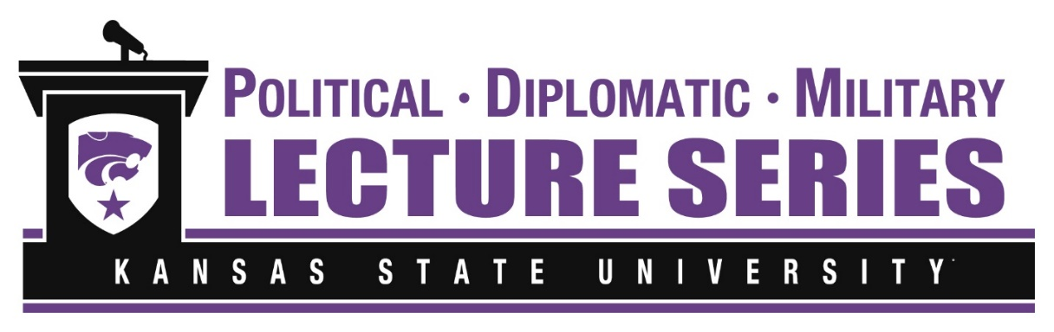
7-10pm-Thursday, May 12th, 2022
KSU Alumni Center-Ballroom
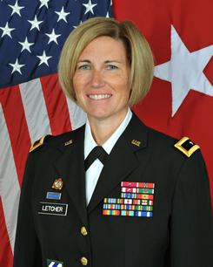
94th Featured Speaker: Brigadier General Michelle Letcher
Chief of Staff, U.S. Army Futures Command
Brigadier General Michelle M. T. Letcher serves as the Chief of Staff of the U.S. Army Futures Command that leads a continuous transformation of Army modernization in order to provide future warfighters with the concepts, capabilities and organizational structures they need to dominate a future battlefield.
Brig. Gen. Letcher is a native of Oak Forest, Illinois, and was commissioned in the Air Defense Artillery branch via the Reserve Officer Training Corps from Illinois State University in 1995. She later became an Ordnance Officer in 1997 where she has lead in a myriad of important assignments. She holds a Bachelor of Arts degree in Social Work from Illinois State University, Normal, Illinois, and a Master of Science in Human Services and Counseling from the State University of New York at Oswego, a Masters in Advanced Military Studies from the Command and General Staff College, and a Master of Arts in National Security and Strategic Studies from Kansas State University, Manhattan, Kansas.

Dear Friend of the PDM Lecture Series,
We are honored to host our second and final PDM lecture this academic year to discuss a very timely issue of defense modernization in the face of new global hostilities and the emergence of new weapons such as hypersonic missiles. Brigadier General Michelle Letcher will share her insights into our strengths and vulnerabilities as a nation as it continually prepares itself to defend our nation.
The PDM Lecture Series continues to hold its special place in our community due to the commitment of our guests to attend and engage in these fine lectures of the nation’s most prominent experts in the field of national security. I would therefore be personally honored if you would grace us with your presence at this event. Information regarding the details of the evening is included below and I do hope to see you in May.
Very Sincerely,
Dr. Art DeGroat
Director, K-State Political, Diplomatic and Military Lecture Series

Please Join Us for the 94rd PDM Lecture
7:00pm-10pm, Thursday, May 12th, 2022 at the Kansas State University Alumni Center
1720 Anderson Ave/Manhattan, KS
(Doors Open at 6:45pm, Advance payment only, please)
Cost: $35.00 per person
Please mail your response with payment no later than May 5th, 2022
Make checks payable to: PDM Lecture Fund #F34210
To Reserve Your Place, Please Mail Payments to:
PDM Lecture Series
c/o KSU Office of Military & Veterans Affairs
24A Anderson Hall, Manhattan, KS 66506
*Please contact Art DeGroat with questions: degroata@ksu.edu 785 210-6570

As We Aim to Re-build our Funding for Another Year of Lectures—Your Charitable Donations are Most Needed

