Laboratory Data from Food Products, Environmental Swabs, and Patient Stool Specimen from the Farm-Associated Illness Outbreak

Pulsed field gel electrophoresis results. Bacterial isolates from growth media are treated with enzymes to cut the genetic material at specific sequences. Pieces of DNA of different sizes react with a dye and are visualized on a gel. Isolates from different sources are compared to determine relatedness based on banding patterns.
Lane 1 2 3 4 5 6 7

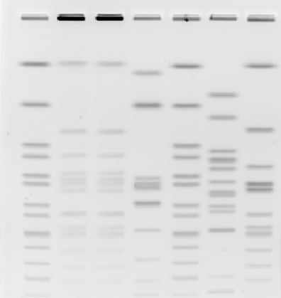
Lane Isolate
1 Size reference
2 Patient #1 stool specimen
3 Unpasteurized cider
4 Ice cream
5 Petting zoo environmental swab
6 Orchard environmental swab
7 Hamburger

Image Source: Delaware Public Health Laboratory

