Microscope Observation Data Table

 | Observations (description or graphic is acceptable) | Number of bubbles in initial slide | Number of bubbles after two minutes | Total number of bubbles created
Yeast with no sugar solution
Yeast with 5% sugar solution
Yeast with 15% sugar solution
Yeast with 30% sugar solution

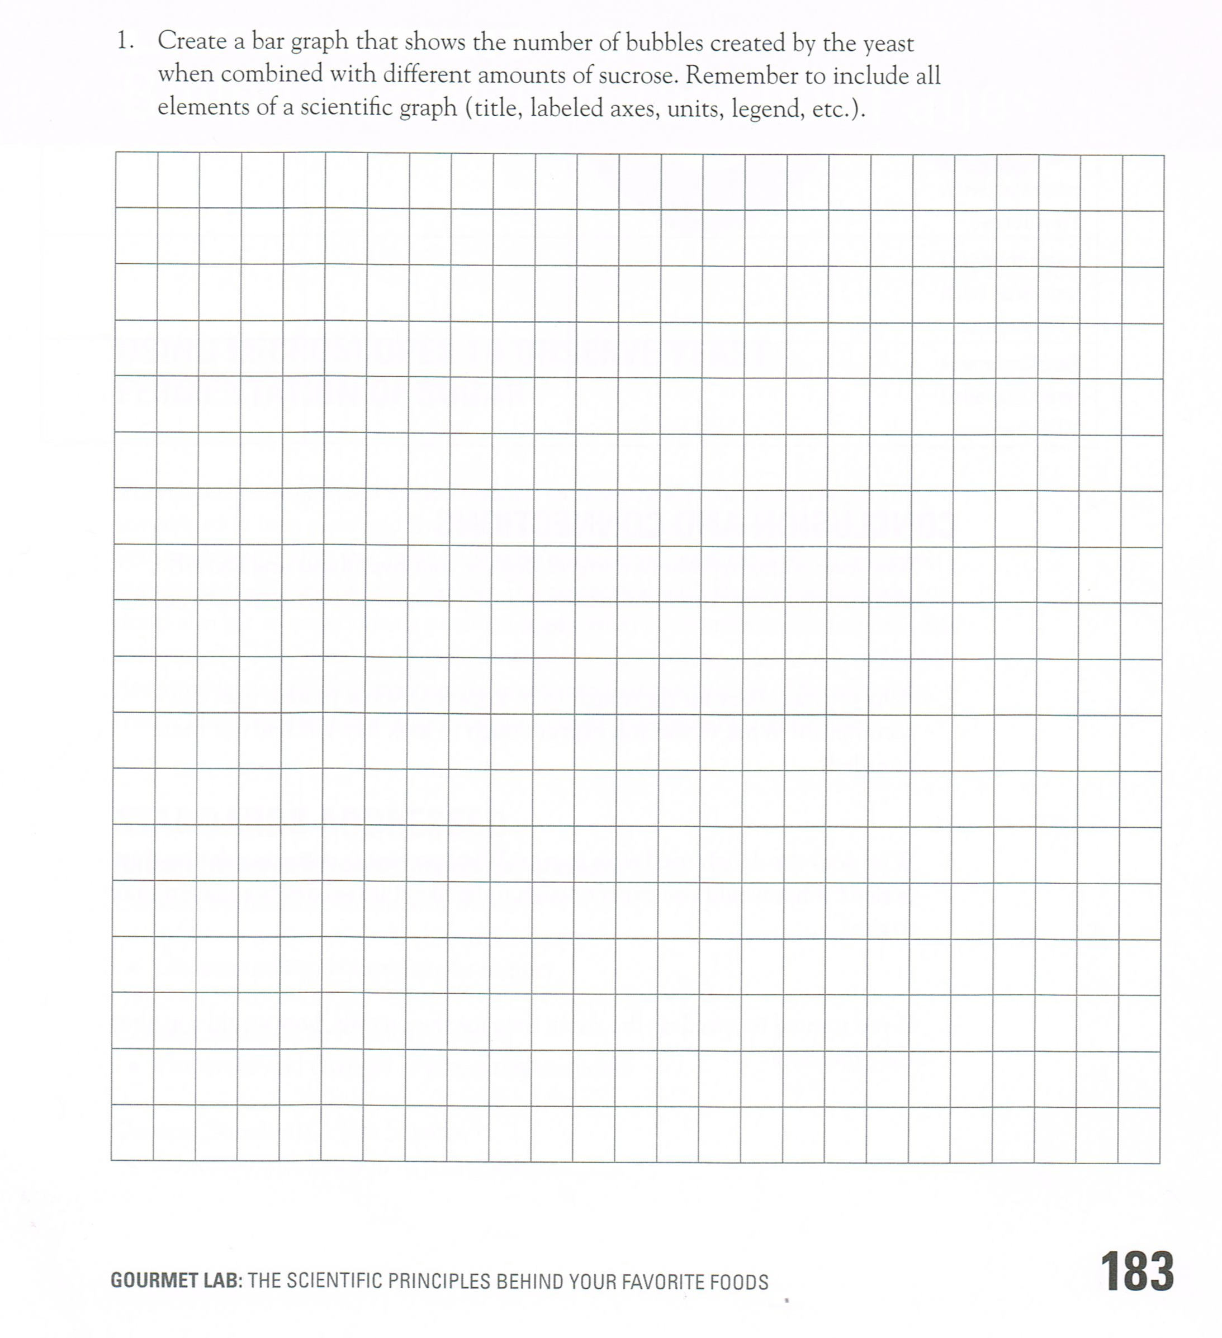
Create a bar graph that shows the number of bubbles created by the yeast when combined with different amounts of sugar. Remember to include all elements of a scientific graph (title, labeled axes, units, legend, etc.)

