ASL 1, EDSP 415
Beginning American Sign Language

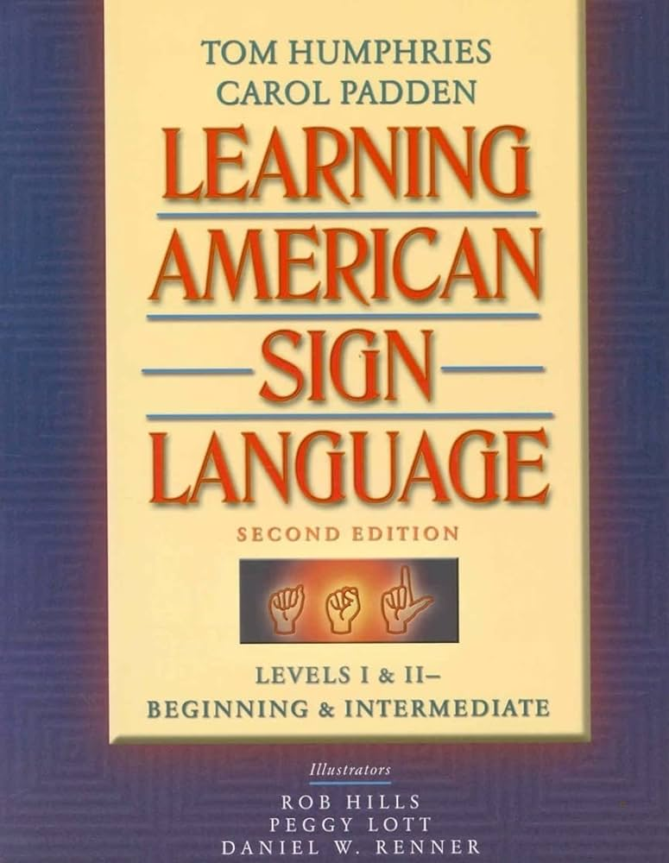
Are you interested in learning basic American Sign Language? If so, then this is the class for you. You will be learning the manual alphabet, numbers, and approximately 500 signs. Also learn about Deaf culture, applications of sign language in education, and the history of American Sign Language. We will also learn about some of the technology currently being used by those that are deaf.

Instructor:
Contact Info:

Class Information:

Natalie Beharry
202 Holton Hall
785-532-6441
nbeharry@ksu.edu
Fall 2024
TU 5:30pm - 6:45pm
3043 Business Bdlg
Please contact me if you have any questions about the course.

