REQUEST FOR FOREIGN OR DOMESTIC WIRES

- Requests for Wires MUST be received in the General Accounting Office 2323 Anderson Ave. before 11:00 am. to be processed the same day (payments go out the day after the document is processed).
  - Wire requests may be emailed to bpc@ksu.edu to expedite processing; originals may be kept on file in the department office.
- All wires, regardless of final destination or currency,
  - Are processed on APV’s
  - Payment indicator will be “A”
  - Submitted with a completed Wire Request form (Foreign or Domestic; found in eForms):
    - Please include SWIFT code, IBAN or Acct #, AND Bank Acct Name
    - At bottom of doc add
      - Agency number 367
      - Contact name – your name
      - Phone number – your work number (including area code)
  - Check type is STATE
  - Wire type will be either
    - Foreign Currency
    - US Dollar
  - If sending foreign currency call Brenda Linder in Topeka 785-296-4144 to get currency exchange rate prior to submitting voucher to DFS
    - Wires in Foreign Currency MUST be processed the same day as the rate is obtained from the State office
      - Conversion rates are good for 24 hours after obtaining from the State office – all approvals and processing must be completed within that 24 hours for rate to remain the same.
    - If sending Foreign dollars, the amount on voucher will differ from the amount on the request form:
      - The APV will reflect the U.S. Dollar conversion rate.
      - The amount on the Wire Request form will reflect the foreign dollar amount on the invoice.

- Request for WIRE in FOREIGN CURRENCY

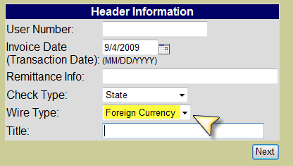

  - HEADER INFORMATION
    - Select check type: STATE
    - Select wire type: FOREIGN CURRENCY
  - VENDOR INFORMATION
    - Vendor is the company the wire is paying, based on the Invoice information
  - AGENCY INFORMATION
    - Your department information
  - FUNDING INFORMATION
    - Object codes for wires are the same as for any other APV
    - Code $25 wire fee to E2690, using NonGrant funding, for all payments sent to a foreign bank
      - There is no wire fee for payments going to a U.S. bank
  - PURCH INFORMATION (Complete if necessary for purchase)
  - DESCRIPTION INFORMATION
    - Complete as you would for APV
    - Add separate line regarding wire fee and amount
    - Do not include any of the vendor’s bank information.
  - FLAG INFORMATION (Complete if necessary for purchase)
  - TRUSTEES (Complete as you normally would)

- Request for WIRE in US DOLLAR

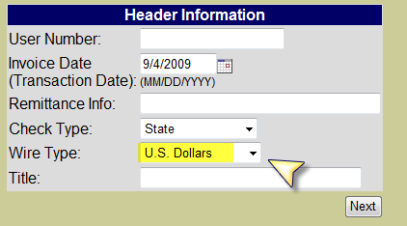

  - HEADER INFORMATION
    - Select check type: STATE
    - Select wire type: US DOLLAR
  - VENDOR INFORMATION
    - Vendor is who the check is made out to based on the Invoice information
  - AGENCY INFORMATION
    - Your department information
  - FUNDING INFORMATION
    - Object codes for wires are the same as for any other APV
    - Code $25 wire fee to E2690, using NonGrant funding, for all payments going to Foreign vendors
      - There is no wire fee for payments going to a U.S. bank
  - PURCH INFORMATION (Complete if necessary for purchase)
  - DESCRIPTION INFORMATION
    - Complete as you would for APV
    - Add separate line regarding wire fee and amount
    - Do not include any bank information
  - FLAG INFORMATION (Complete if necessary for purchase)
  - TRUSTEES (Complete as you normally would)

