Curriculum Plan PROCEDURE (Changes)
(Course picker)

Start proposal |
Click +New Proposal

Select Curriculum – Change – Major v23.24
Curriculum – Change – Minor v23.24
Curriculum – Change – Certificate v23.24
Curriculum – Change – Major – K-State Core Only – v23.24

Click Start Proposal
In Search box, Name = zTemplate
--may use wildcard *

Select catalog =
Source: Undergraduate programs: select 2023-2024 Undergraduate Catalog
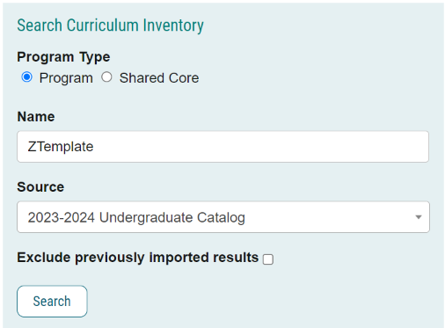

Click Search
Click
Click Build Proposal

OR

Select catalog =
For Graduate programs: select 2023-2024 Graduate Catalog
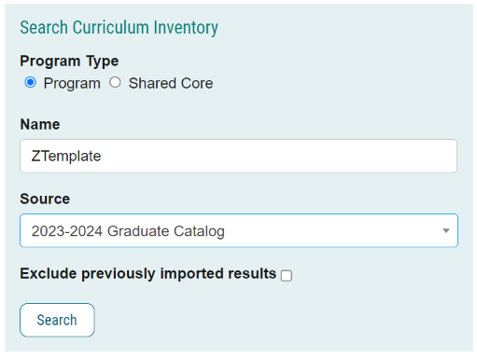
Click Search
Select for Undergraduate Templates:
- ZTemplate (BA) AS – only for use for College of Arts & Sciences Bachelor of Arts Majors
- ZTemplate (Bachelors)
- ZTemplate (BS) AS – only for use for College of Arts & Sciences Bachelor of Science Majors
- ZTemplate (Minor)
- ZTemplate (Undergraduate Certificate)
- Z Template Academic Degree Map

Select for Graduate Templates:
- ZTemplate (Accelerated)
- ZTemplate (Doctorate)
- ZTemplate (Graduate Certificate)
- ZTemplate (Masters)

Choose the template you are looking to launch and Click to Build the Proposal

Department |
Confirm correct department is displayed

Program/Plan Name |
If the title of your program remains the same:
--do nothing
If the title of your program is changing:
--Edit the field to reflect the new program name
Click Save All Changes

Curriculum Plan field: |
--three icons are available giving you viewing options:
1-View Curriculum Courses tab: displays all courses currently available in the program
2-View Curriculum Schema tab: displays all current cores within the program
3-Preview Curriculum button: pop-up window displays the current curriculum

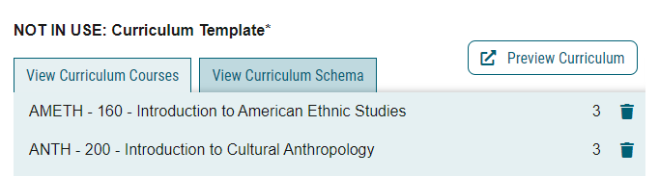

1-View Curriculum Courses tab: displays all courses currently available in the program |

--import courses to add courses to the program
--Once courses are added, assign to the appropriate core using the View Curriculum Schema module
--Courses deleted from cores should also be deleted here as well

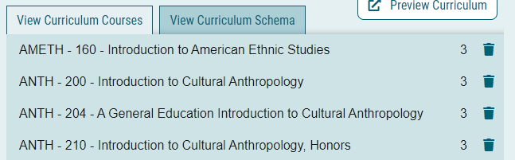

Import course (course currently in catalog)
In View Curriculum Courses, click Import Course
A new window will open: Import Data Into Your Proposal
Select [catalog]
--2023-2024 Undergraduate Catalog (for undergraduate programs)
--2023-2024 Graduate Catalog (for graduate and accelerated programs)
In Filter Courses, click Or add filter, click dropdown, and select Prefix
Type [prefix ](i.e. ENTOM)
Click Search Available Curriculum

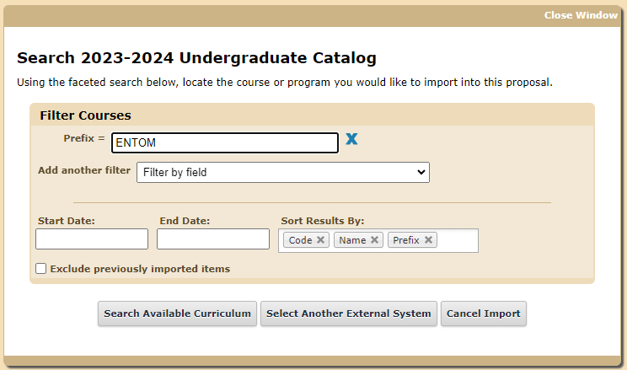

Search Results displays a list of courses
Select {courses}
--Scroll down or click Next to find courses
--Click on a course to select
--Courses turn YELLOW when selected
--Click again to de-select if one is mistakenly chosen
--multiple courses can be selected
Scroll to bottom to review Selected Courses.
Courses may be removed by hovering over the course and clicking the blue X to the right
Click Add Courses to Proposal
Click Save All Changes

Repeat to add all courses

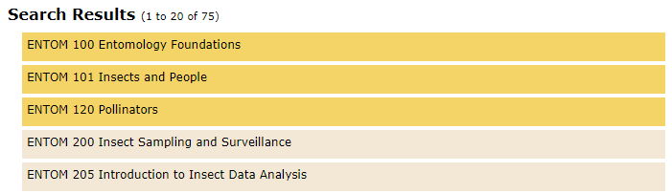

Add course (new course that is proposed but not currently in catalog)
Click Add Course
Enter Prefix
Enter Code: {course number}
Enter Name: use format = **NEW COURSE {title of course} (X credits)
Click Add Course
Click Save All Changes

Note: once the new course is approved and added to the catalog, and prior to importing this program into the catalog, this placeholder course must be replaced by the imported course

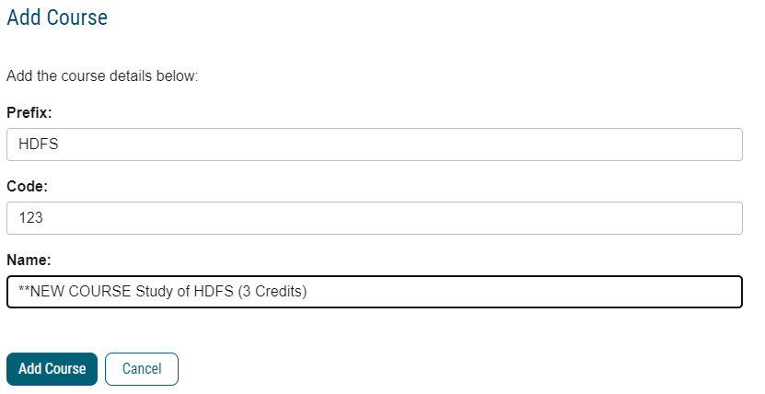

Delete course
Click Trash icon
Click Save All Changes

2-View Curriculum Schema tab: displays all current cores within the program. |

What it does:
--Click on the core/sub-core name once to expand
--This view allows you to:
--view/edit core title and core description (as needed)
--view/edit courses associated with the core (as needed)
--add courses (must first add the courses using “View Curriculum Courses”)
--delete courses (click Trash icon)
--move courses within core using drag/drop
--move courses between cores (using the Add Courses button/Delete icon)
--add custom text

Kansas State University Core
(NEW) K-State Core requirements and course lists may be automatically included in the template
No updates are required in this requirement
If desired, click down-arrow to expand requirement and view courses

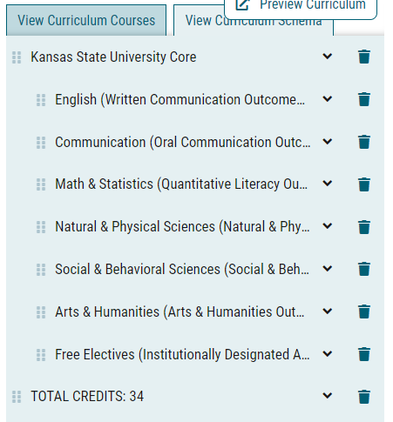

Requirements
Requirements are displayed

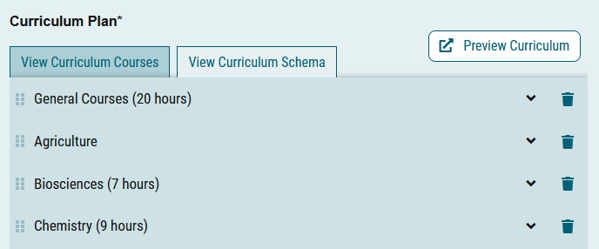

Click on a requirement to expand the entry area

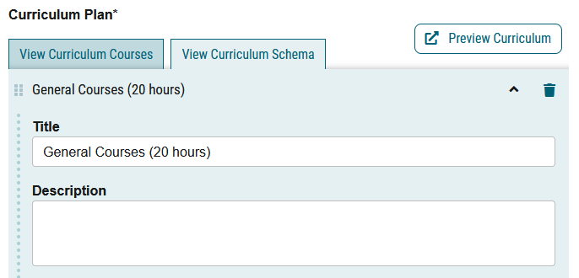
Update Title, as needed
Update Credit Hours, as needed
Update Description, as needed
--Enter instructions that pertains to whole requirement.
Examples:
“Select 4 credits from:”
“Select 2 courses from:”
“Select from:”
Click Save All Changes

This description should be utilized if further explanation (beyond the title) of the nature of the grouping, or if there are additional requirements that coincide directly with this grouping of courses are desired.

Courses
Remember, you must first import courses under the “View Curriculum Courses” tab in order to choose them in this step

Click Add Courses
Select {courses}
--Courses turn blue when selected
--Click again to de-select if one is chosen mistakenly
Click Add Course

Courses added to the bottom of the core, and sorted by course number by default
To move a course, click and drag it to the desired location

Click Save All Changes

To group courses or include “and/or” situations
Use custom Text to add clarity and notations to your requirements, and to include “and” and “or” notations

Click Add Custom Text

Name (required, will not display on the gateway) = Blank
Insert a blank line: Position = After
Click Add Text

Name = Or
Insert a blank line: Position = Before,
Rich text box = OR (in caps and bold)
Click Add Text

Name = And
Insert a blank line: Position = Before,
Rich text box = AND (in caps and bold)
Click Add Text

Name = Blank
Insert a blank line: Position = After, click Add Text

Click and drag text to the desired location(s) to clarify the meaning of the requirement

Click Save All Changes

Examples:
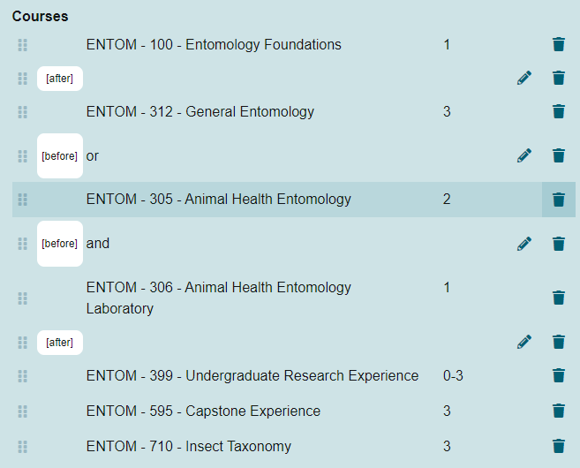

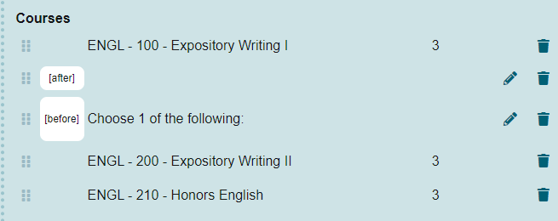

To Add Custom Text
Whether editing or adding courses within a core, you have the option to Add Custom Text.
Custom text is text that provides clarification for options between courses, etc.
You must add a course before you may add custom text
--if no courses are selected in this requirement,

Examples of custom text:
o “or” when able to choose between two or more courses,
o “Select one course from the following:” before a list of courses
o other text
o footnotes
o BIOCH***
o ENTOM 400 or above

Note: If custom text is used to only describe a single requirement, then the Requirement “Description” field can be used instead.

Click Add Custom Text

Name (required, will not display on the gateway) = {give it a name}
Insert a blank line: Position = After, click Add Text
Rich text box = {enter text here}
Click Add Text

Click and drag text to the desired location(s) to clarify the meaning of the requirement

Click Save All Changes

To Indent a Requirement
Click and drag text right/left to the desired location(s) to indent and clarify the meaning of the requirement
Click Save All Changes

Add a Core
If you need additional requirements than provided in the template:
• In View Curriculum Schema, click Add Core.
• You will see a new row added to the end of the list titled New Core.
• Click once on New Core and type in the title, and description (optional).
• You can then add courses to this core, as referenced above.
Drag and drop the new core to the desired location

Delete course
Click Trash Can icon next to yours
Also remember to delete from “View Curriculum courses” view

Delete Core
Delete any unused requirement shells, if needed

Click Delete Core from Proposal icon to right (trash can icon)
Click Delete Core
Click Save All Changes

3-Preview Curriculum button: pop-up window displays the current curriculum |
(catalog view)
--good place to ensure credits add up to 120
--This view does not allow editing; click View Curriculum Schema tab to edit

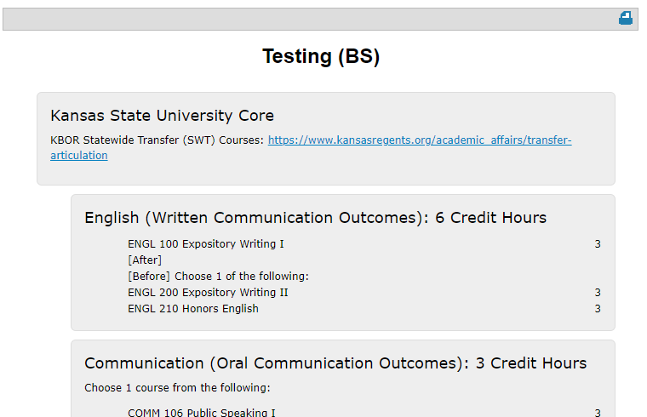

Show Curriculum Preview with Markup
--pop-up window displays the current curriculum in catalog view
--review for accuracy
--Make sure that ALL credit hours add up to the appropriate total (include all categories such as K-State Core Requirements, Program Requirements, Programs/Major Requirements)
--Once a proposal is launched, clicking the red pencil icon allows users to view mark-up reflecting changes in the curriculum

Example for CHANGE proposals:

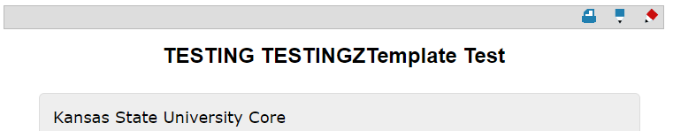
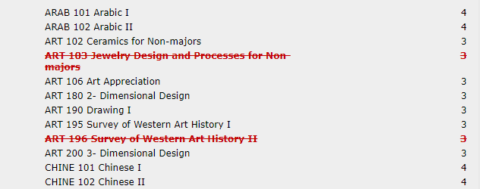

Launch proposal
Click the Launch and Validate Proposal icon

Submit “Academic Degree Map” proposal
REMEMBER: If you are updating a bachelor’s program, as required by the new K-State Core general education, you must also submit a separate proposal in Curriculog to update the Academic Degree Map

