Background
Cognitive and Neurobiological Approaches to Plasticity (CNAP) Center
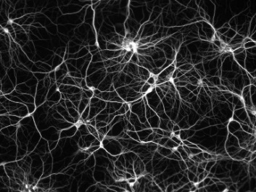
Changes that occur in the brain as a function of growth, aging, or experience are referred to collectively as plasticity. Plasticity is essential for adaptive behaviors, and is critical for healthy functioning. CNAP researchers investigate plasticity in humans and animal models using basic and translational research techniques. The overarching goal of this recently-funded center is to understand the mechanisms of cognitive and neural plasticity with the ultimate goal of promoting healthy functioning.

Description

The CNAP Center of Biomedical Research Excellence was funded in July of 2017 by a $10.6 million, five-year grant from the National Institute of General Medical Sciences. CNAP is housed at Kansas State University in the Department of Psychological Sciences and is partnered with the Department of Psychology at Wichita State University. The grant will support four projects, three research cores, and three programs as well as a host of other research activities. The research cores include:

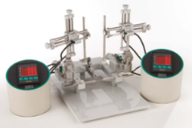
- The Behavioral Neuroscience core, housed in the K-State Department of Psychological Sciences, which will be modernized to enable the use of cutting-edge neuroscience techniques for application to animal models of disease.
- The Neuroinformatics core, housed in the K-State Engineering Complex along with the Beocat Computing cluster, which will facilitate the visualization and analysis of large neuroimaging data sets.
- The Driving Simulator core, housed at Wichita State University, which will support research on plasticity and driving behavior in a state-of-the-art virtual reality immersive driving environment with integrated eye tracking capabilities.

Relevance

Research projects will occur along three themes:

- Aging and neurodegeneration research will connect with multi-disciplinary centers on aging at Kansas State and Wichita State Universities. The average age of the US population has been increasing significantly, and persons over 65 now represent about 15% of the population with projections of about 22% by 2040. Understanding factors that promote healthy aging (both in terms of cognitive performance and delaying disease onset) can have a major financial impact in addition to the overall impact on the well-being of the US population. Our projects related to aging are designed to understand mechanisms that impact on important everyday functioning, which is critical for maintaining an independent lifestyle.
- Neurobiology of reward and decision will examine neuronal plasticity of reward valuation, with links to decision making and alcohol abuse. Given the numerous disorders associated with deficient reward valuation and decision making processes, including ADHD, drug abuse, gambling, and obesity, there are rich opportunities for CNAP to make a significant impact on the field in these areas. Our projects in this area will examine factors that influence the development of alcohol abuse in adolescence/early adulthood and the neural circuits of flexible decision making.
- Translational/comparative neuroimaging is an area of recent growth and additional planned growth at Kansas State. With the establishment of a new small-animal imaging core in the Department of Chemistry coupled with plans to grow human neuroscience in the Department of Psychological Sciences and the collaborative use of human neuroimaging facilities at University of Kansas Medical School, we are in a position to be able to support both animal model and human neuroimaging techniques. These techniques can be implemented to answer questions relating to aging and neurodegeneration as well as work in the neurobiology of reward and decision, significantly advancing our understanding of neuronal plasticity mechanisms within these areas. Neuroimaging is an essential technique for understanding neuronal plasticity, and we aim to develop a strong focus on this area over the course of the next five years.

Agency Contact Information

National Institute of General Medical Sciences
Dr. Hongwei Gao, Program Director
301-827-7819
hongwei.gao@nih.gov

