Online Learning Design for Diversity and Inclusion (activity)

Directions: Each of the participants (or participant pairs or groups) will take on one of the following questions. They will create a plan and will share their insights with the group in 20 minutes.
[Aedes aegypti in Resting Position by E.A. Goeldi (1905), released via Wikimedia Commons]

1. What sorts of diversity can you expect in a global audience? Why?

2. How would you consider the “whole learner” in your training design plan? The many diversities in each person? The fact that each person is an individual in a context and in a culture…?

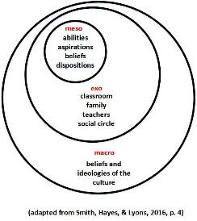

3. What are some strategies and tactics to use to appeal to various segments of this global audience? Why is the burden on the trainer to connect with the global range of learners?

4. Where would you get your informational contents for the training? (Remember, this health issue is a live and evolving dynamic issue.) Where does credibility come from in this case?

5. How do you avoid offending learners in your instructional design? How can you be culturally sensitive? Respectful?

6. What technologies (broadly speaking—and not just digital ones) would you employ for your online training? Why?

7. Would you “version” your trainings and messages? Why or why not?

8. How would you measure the effectiveness of your training? Why?

9. Please rank-order the following types of inclusions for this particular exercise. Which of the following are most relevant in this training creation exercise? (The most important is 1, then, 2, in descending order.) Why?

_______ Inclusion for demographics
_______ Inclusion for culture
_______ Inclusion for language
_______ Inclusion for learning preferences
_______ Inclusion for accessibility (2017, SHJ)

